**LESSON 1: GLOBALIZATION**

**GLOBALIZATION**

* The act or *process of globalizing* or the state of being globalized.
* It is the interconnectedness of people and business across the world that eventually leads to global, cultural, political, and economic integration.
* It is the *increasing interaction* of people, states, or countries through the role of the *international flow* of money, ideas, and culture. Thus, globalization is primarily focused on the economic process of integration that has social and cultural aspects.

**GLOBALIZATION DEFINED BY OTHER AUTHORS**

“*Globalization as process by which the people of the world are incorporated into a single world society*.” – **Martin Albrow** and **Elizabeth King**

“*Globalization as the compression of the world and the intensification of the consciousness of the world as a whole.*” – **Prof. Roland Robertson** (sociology) 1992, University of Aberdeen

|  |
| --- |
| **THE COMPETING CONCEPTS OF GLOBALIZATION** |

**GLOBALIZATION AS A PROCESS**

The **British broadcasting corporation (BBC)** emphasized that globalization is “ *a process by which the world is interconnected as a result of massively increased trade and cultural exchange which has increased the production of goods and services and has been taking places for hundred of years, but has speed up enormously over the half century*”

**Thomas Larson** (2001) in his book “t*he race to the top: the real story of globalization” has defined the term as the “process of world shrinkage, of distance getting shorter, things moving closer.*”

**GLOBALIZATION AS CONDITION**

Thomas Larson (2001) Defined globalization as a “*condition of integration of economics, political, and economic exchanges made possible largely by advances in communication, transportation, and infrastructure*”. It is also described as the spread of connectivity of economic and cultural life all over the world.

The **United Nation conference on Trade and Development (UNCTAD)** defines economic globalization as “*closer integration of national economies through trade and financial flows as well as cross-border migration of people*.”

**GLOBALIZATION AS AN ERA & SYSTEM**

**Thomas Fredman’s** best-selling book “The Lexus and the Olive Tree” gives a relatively balanced and oft-cited definition of globalization which he considered as both an era and a system “that not a static but a dynamic ongoing process, globalization involves an inexorable interrogation of markets, nation-state to reach around the world farther, faster, deeper, and cheaper than ever before, and in the way that is also producing a powerful backlash from those brutalized and left behind by this new system.”

|  |
| --- |
| **THE PHILOSOPHIES OF THE DEFINITION OF GLOBALIZATION** |

**CAPITALISM**

* Capitalism is the **dominant economic framework** and system in many parts of the world today.
* It is primarily premised on the **“profit motive”**
* It promotes claim that seeking profit is the basic aim of many individual entity in this world’ the profit notice partly explains why.

**NEOLIBERALISM**

* Neoliberalism adherents further build on the profit motive by asserting that for capitalism to thrive, markets should be free from government intervention claiming that “free markets and free trade will set free the creative potential and entrepreneurial spirit which is built spontaneous order of any human society. And thereby led to more individual liberty and well-being and more efficient allocation of resources.”

|  |
| --- |
| **DIFFERENT DEFINITIONS OF GLOBALIZATION** |

**GLOBALIZATION**

* Globalization is a long-term process rather than a phenomenon.
* Globalization emerges from technological revolution. The new knowledge industry and the interconnected dynamic webs are vital for enhancing globalization.
* Globalization is not just about economic phenomenon, it also compress political, social, and cultural aspects.

|  |
| --- |
| **VARIOUS CONCEPTS OF GLOBALIZATION FROM EXPERTS** |

**WORLD HEALTH ORGANIZATION**

* Globalization means the speed up of movements and exchange (of human beings, goods and services, capital, technologies or cultural practices) all over the planet.

**MCGREW (1990)**

* Defined globalization as something that is composed of multiple sameness and interconnectedness that go beyond the nation-states.

**MANFRED STEGER’S**

* The term globalization applies to a set of social process that appear to transform our present social condition of weakening nationality into one of globality.

**OTHER SCHOLARS**

* Globalization as a multidimensional group of social procedures that build, accelerate, and intensify worldwide interaction while, at the same time, nurturing in people an increasing consciousness of deeping linkage between the local and the far-off.

**WORKING DEFINITION OF GLOBALIZATION**

* Globalization is the word used to describe the growing interdependence of the world’s economies, cultures, and populations, brought about by cross-border trade in goods and services, technology, and flow of investment, people, and information.

**LESSON 2: THE GLOBAL ECONOMY AND MARKET INTEGRATION**

**Economic Globalization**

* Economic globalization is driven by the"*growing scale of cross -border trade of commodities and services*."
* Economic globalization focuses on increasing *economic trade interrelations* among countries.
* Global Economic Integration means that separate production operations are functionally related to each other and form a unified product or service.
* This is governed by neoliberal principles with the role of the market as a central driver of economic activities, with less government interventions.
* Economic globalization entails global industrial restructuring and readjustments where developed countries play a dominant role.
* Global Economic Integration means that separate production operations are functionally related to each other and form a unified product or service. This results to efficient management of economic operations from different areas in the world.

**Global Economic Integration**

* Economic integration means that separate production operations are functionally related to each other and form a unified product or service.
* A unified product or service is formed by various production processes that are functionally related to one another. include the reduction or elimination of trade barriers, such as tariffs and quotas, as well as the liberalization of investment and financial markets.

|  |
| --- |
| **Actors that Facilitate Economic Globalization** |

**International Economic Organization**

* **International Monetary Fund** (IMF), **World Bank**, and **Organization for Economic Cooperation and Development** (OECD). These organizations help countries to develop neoliberal policies. They also help to facilitate trade and development discussions among various states.

**Regional Economic Organization**

* Regional Organizations such as **Association of Southeast Asian Nations** (ASEAN) and **North American Free Trade Agreement** (NAFTA). These organizations promote regional agreements and standards that facilitate better trade and exchange of knowledge, human resources, and regional cooperation.

**Multinational Companies (MNC's)**

* Considered to be the main carriers of economic globalization. These companies are believed to promote growth and employment by creating new jobs, realize new investments, bring in new technologies, and allow host economies to integrate and upgrade in the global value chain. They can be in the form of trade companies such as Royal African Company, and Hudson Bay Company, fast-food chain companies such as McDonalds and Starbucks, and technology companies such as Samsung and Apple.

**Central Banks**

* Considered one of the most powerful institutions in the world economy since they can lead economic development, and some authors contend that central bank governors are more influential in their own national economy than some politicians.
* They have the ability to influence monetary policy, which can affect interest rates, inflation, and overall economic growth.

**Global Civil Society**

* Considered the major driver of economic globalization.
* Either composed of individuals or groups of individuals disadvantaged by the effects of the globalization of the world economy, they protest and seek alternatives while on the other hand, global social movement constituting a basis for an alternative to a new world order.
* **Example**: International Trade Union Confederation and the World Wide Fund for Nature.

|  |
| --- |
| **DEFINING MODERN WORLD SYSTEM** |

**Immanuel Wallerstein**

* American sociologist and economic historian
* 13th president of the **International Sociological Association**
* Discovered the **Modern World-System Approach** in **1974**.

**Modern World-System globalization**

* A critical reference in the theorization of globalization
* According to Wallerstein it is specifically a
* capitalist world economy with capitalism defined as “the endless accumulation of capital” It is a geographical division of labor. While the basic linkage is economic which is reinforced by political and cultural factors.

|  |
| --- |
| **Global Divide** |

**The Tripartite World-System**

* Pertains to the stratifications among nations
* Divides the nations and areas of the world into three; core, periphery and semi-periphery

**CORE**

**1st World Countries**

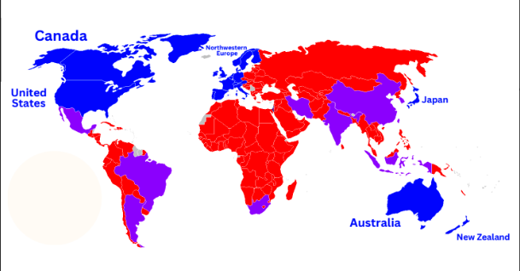

* Highly independent, wealthy and powerful.
* They dominate the capitalist world-economy
* Canada
* United States
* North Europe
* Japan
* Australia
* New Zealand
* (United Kingdom, Sweden, Norway, etc.)

**PERIPHERY**

**3rd World Countries**

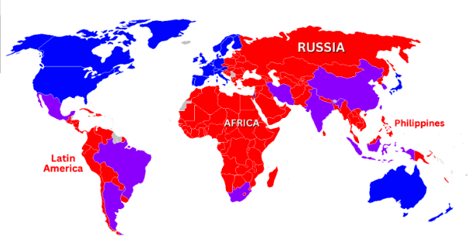

* Countries that lacks strong central government and is heavily exploited by the core.
* Dependent with other countries and rely the economic situation base on the economic stability and economic balance of the core.
* Philippines
* Russia
* African Countries
* Asia
* Some Latin America (Columbia, Chile, Uruguay, Peru)

**SEMI-PERIPHERY**

**2nd World Countries**

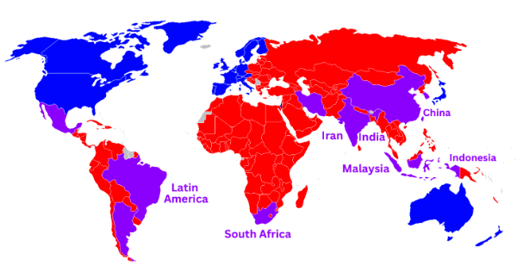

* Countries that lies in the two extremes, the core and the periphery.
* They are buffers which means there is a big impact to the semi-periphery if something happens to the core and/or periphery. They either exploiting or being exploited
* Latin America (Brazil, Argentina)
* South Africa
* Iran
* India
* China
* South Korea
* Malaysia
* Indonesia

**EXTERNAL AREAS**

**Introverted Countries**

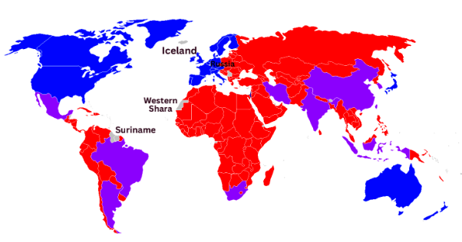

* Countries who maintained their own economic system
* They managed to remain outside of the modern world economy
* Limited foreign commercial influence
* Iceland
* Russia
* Western Shara
* Suriname

|  |
| --- |
| **MARKET INTEGRATION** |

**MARKET INTEGRATION**

* is a process by which economies are becoming more interdependent and interconnected in terms of commodity flows including externalities and spillover of impacts.

**International Financial Institutions**

* International Financial institutions or iris we institutions that provide support through loans or grants and technical advices to promote a country's economic and social development.

**Corporations**

* Corporations are private institutions that produce or manufacture goods, products, and services for a more expanded market usually at the reach of regions or the world. Transnational corporations (TNCs) have a more complex setting where each foreign subsidiary is given some freedom to develop its own product lines and marketing compared to multinational corporations (MN(s), more on exporting their products and services.

**Horizontal Integration**

* Horizontal integration happens when a firm gains control of other firms performing similar marketing functions at the same level in the marketing sequence.

**Vertical integration**

* Vertical integration happens when one company
* owns the operations and products from one stage to the other along the supply chain.
* The International Financial Institutions and their Role in the Global Economy

**The International Financial Institutions and their Role in the Global Economy**

**IFIs (International Financial Institutions)**

play a significant role in global economic development by providing loans, technical assistance, and policy-based lending to promote macroeconomic stability, infrastructure and systems development, sectoral reforms, and safety nets.

IFIs also work with the private sector for investment and policy reforms to promote private sector expansion.

However, some critics question IFIs' legitimacy due to the majority

of its shareholders and policy-making powers being held by powerful, rich nations and leadership being from developed

countries.

IFIs' effectiveness has also been questioned by some sectors due to controversies surrounding certain investments and lack of social safeguards.

IFIs' loans come with certain conditions, known as conditionality, which have been contested by some sectors as imposing Western free-market policies on developing countries.

Financial capacity and sustainability of IFIs is also a concern due to decreasing income base, increasing demand, and middle-income countries limiting loans due to higher transactional cost and conditionality.

**From Barter to Bitcoin: A Summary of Global Economic History**

* The modern capitalist world economy flourished between 16th to 18th centuries.
* The start of the modern global trade leading to 1914 was considered the first period of globalization with trade, capital and immigration flows growing tremendously.
* From Second World War to the late 1990s, the modern international economic enabling architecture was established.
* Political changes like the fall of the Berlin Wall, establishment of regional networks, and trade agreements resulted in trade liberalization and free flow of capital in the world.
* The euphoria on globalization and global free trade was put into question with the 1994/95 Mexico crisis, when Mexico’s multi-billion loan from IMF created a negative spillover effect.
* The advent of the modern internet, the WTO establishment, and formal entry of China into the trading system through its accession to international financial institutions, marked the third wave of market integration. Despite the world economy boom, the global debt crisis, political and civil unrests resulted to market crash and started the war on terror that affected global diplomacy and economy.
* As the world enters the "Fourth Industrial Revolution", slower economic growth, political destabilization, and diffusion of power are predicted.

**Global Corporations** are major players in

globalization and the modern capitalist market. The number of global corporations from emerging market economies listed in the Fortune Global 500 rose from 47 firms in 2005 to 95 in 2010.

Global corporations are commonly referred to as multinational corporations (MNCs) and transnational corporations (TNCs)

MNCs provide central decisions while TNCs provide individual foreign market investment to have their own operations and systems.

Capital flows have started to change from the dominant North-North/North-South to South South and South-North capital flows, with most of the South-North coming from China and India.

**LESSON 3: GLOBAL INTERSTATE SYSTEM AND CONTEMPORARY WORLD GOVERNANCE**

**What is a nation, a state, and a nation-state?**

* A State is an independent, sovereign government exercising control over a certain spatially defined and bounded area, whose borders are usually clearly defined and internationally recognized by other states.
* A nation is a group of people who see themselves as a cohesive and coherent unit based on shared cultural or historical criteria. Nations are socially constructed units, not given by nature. Their existence, definition, and members can change dramatically based on circumstances.

**State**

* A legal and political entity
* Linked to a territory
* Exists with sovereignty
* Established consciously
* United by laws

**Nation**

* A socio-cultural entity
* Linked to a group people
* May exist even w/o sovereignty
* Can be created unconsciously
* United by bond and shared history

[States v. Nations](https://youtu.be/vWJVnsMd0MU)

**Nation-state**

* A Nation-State is the idea of a homogenous nation governed by its own sovereign state—where each state contains one nation. This idea is almost never achieved.

**What are the effect of globalization on nation-states?**

1. Imposing forced choices upon nation-states
2. Establishment of economic and political integrations
3. Establishment of international laws and principles
4. The rise of transnational activism (TNA)
5. Creation of New Communication Network

**What is a global interstate system?**

* Chase-Dunn defines an interstate system as "a system of unequally powerful and competing states in which no single state is capable of imposing control on all others." These states are in interaction with one another in a set of shifting alliances and wars, and changes in the relative power of states upset any temporary set of alliances leading to a restructuring of the balance of power" (Chase-Dunn, 1981:20). Thus, an interstate system is the form of governance for globalization (Chase-Dunn,1981).

**Institutions that govern international relations**

* The governance of the nation-state governments over the fast-growing globalization became limited and went beyond their scale. To address the regional and global issues it became the role of the non-state actors to address these issues.
* These are the several institutions that govern international relations and affairs.

**(UN) United Nations** - This institution is seen as the world governance facilitator with its 192 state members.

The regional commissions are groups of officials from different countries who instruct and debate. They are also responsible for making specific laws and rights for their respective regions' economic and social developments.

* Economic Commission for Africa (ECA)
* Economic Commission for Europe (ECE)
* Economic Commission for Latin American and the Caribbean (ECLAC)
* Economic and Social Commission for Asia and the Pacific (ESCAP)
* Economic and Social Commission for Western Asia (ESCWA)

There are also global institutions that provide loans to middle-income countries and even private sectors for the development of countries, create markets, and improve local economies.

* The World Bank (WB)
* International Bank for Reconstruction and Development (IRDB)
* International Development Association (IDA)
* International Finance Corporation (IFC)
* Multilateral Investment Guarantee Agency (MIGA)

**Internationalism vs. Globalism**

* Internationalism is defined as political, economic, and cultural cooperation between nations, (Roudometof, 2005).
* Sargent (2008) argues that internationalism emphasizes diversity and celebrates multiculturalism
* Globalism is an ideology based on the belief that the flow of people, goods, and information should flow freely across national borders (Roudometof, 2005).
* Globalism focuses more on the economic aspect of the exchange among countries and society (Sargent 2008).

**Internationalism:**

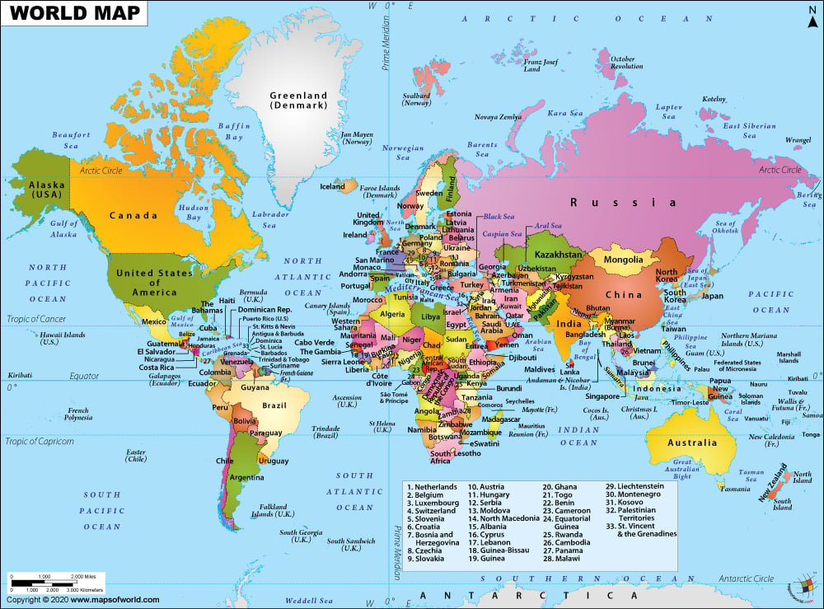

**Globalism:**

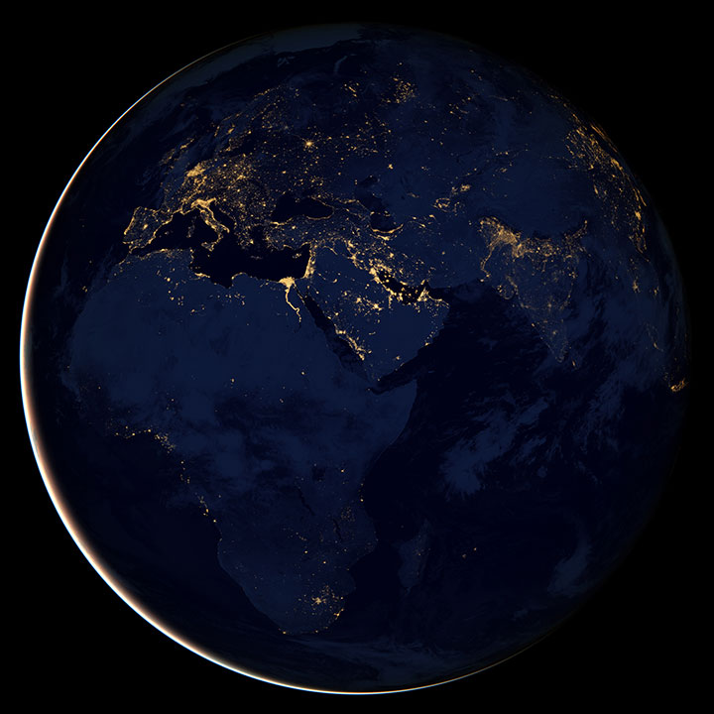

**Internationalism vs Globalism**

In simple terms, internationalism focuses on the cooperation of different countries outside national borders in terms of economics, culture and politics. On the other hand, Globalism refers to the borderless flow of trade, goods, information and people on a worldwide scale. Although Internationalism and Globalism greatly differ in conceptual understanding, yet, they are not exclusive of each other and go hand-in-hand with varying degrees.

**Contemporary Global Governance**

Global governance is the capacity within the international system, at any given moment, to provide government-like services and public goods in the absence of a world government. It is the combination of informal and formal ideas, values, rules, norms, procedures, practices, policies, and organizations that help all actors—states, IGOs, civil society, NGOs, TNCs, and individuals— identify, understand, and address transboundary problems.

**The Uncertainty of the Sovereign Territorial State or Nation-state**

1. The world is entering a development being referred to as the beginning of the “post-American world,” in which the United States retreats and the rest of the world advances in economic power and political influence.
2. After centuries of western countries serving as an example to most, if not all sovereign countries, sovereign territorial state or "nation-state is entering a phase of uncertainty
3. The rigidity interposed by this age-old kind of setup has been disregarded several times in worldwide events: the disintegration of the Soviet Union, the rise of transnational entities within states, global problems requiring global action
4. These supranational forces have weakened the state in three ways:
   1. The creation of a supranational economy wherein the transactions are largely uncontrolled by states, resulting in the restriction of states to direct national economies
   2. Rise of regional or global institutions, such as the European Union, ASEAN, and UN, to which individual countries defer either because they are too small to engage in effective competition international competition or because their economies are so weak
   3. Territorial borders had been made largely irrelevant by the technological revolution in transport and communications.

**Rise of Non-state actors**

* + - 1. Non-state Actors
      2. [Non-State Actors in Global Politics explained in less than 60 seconds](https://youtu.be/ees2-DckbJU)
         1. Transnational Corporations

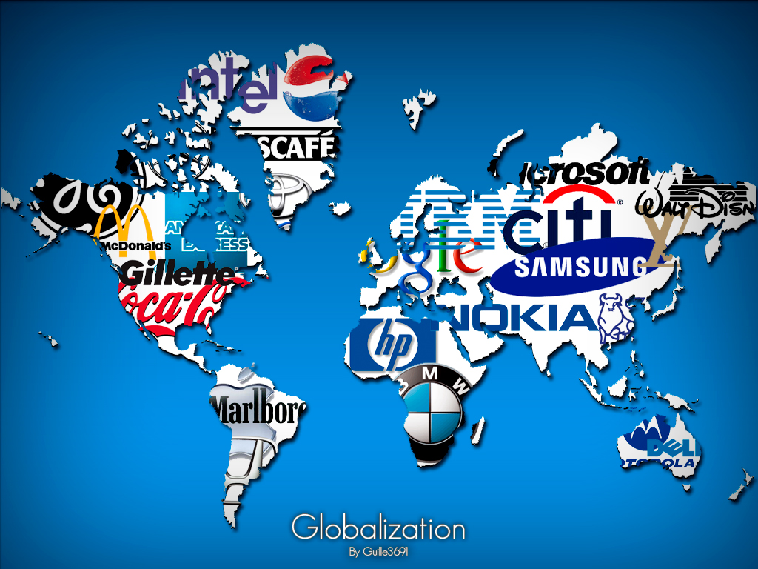

* + - * 1. Non-Governmental Organization

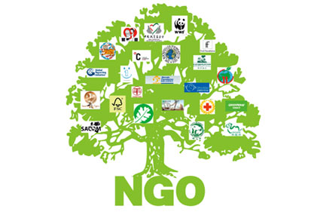

* + - * 1. Inter-Governmental Organization

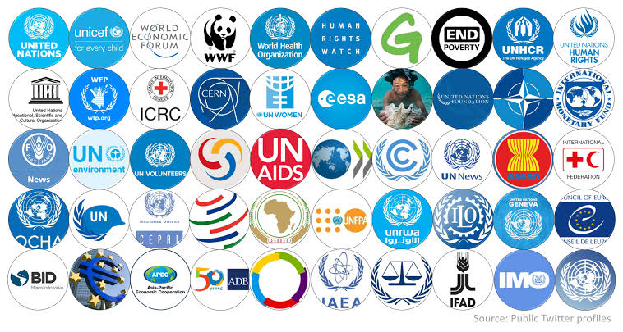

**UN Goals** [What is the United Nations](https://youtu.be/E67ln5yJtyE)

**5 branches of the UN**

**The UN General Assembly.** It is the main decision-making and representative assembly and is responsible for upholding the principles of the UN through its policies and recommendations. It is composed of all member states and headed by a president elected by the member states.

**The UN Security Council.** It can authorize the deployment of UN member states' militaries, can mandate a cease-fire during conflicts and can enforce penalties on countries if they do not comply with given mandates. It is composed of five permanent members and 10 rotating members.

**The International Court of Justice.** It can settle, according to international law, legal disputes between States and give opinions, mostly advisory, on legal questions brought to it by UN organs and agencies.

**The Economic and Social Council.** It assists the UN General Assembly in promoting economic and social development, as well as the cooperation of member states

**The Secretariat.** Headed by the Secretary-General, provides studies, information, and other dates when needed by other UN branches for their meetings.

**Challenges of Global Governance in the Twenty-first Century**

There are still many issues that face the global community in the 21st century. Here are some of the challenges that global governance is trying to address and find solutions to.

Issues about threats to our existence like climate change, weapons of mass destruction, terrorism, pandemics, etc.

Issues about civil rights like discrimination based on ethnicity or national origin, religion, status, age, disability, and sexual orientation.

These are just some of the problems that threaten global security and stability that the global community faces in the 21st century. This threat also adds doubts about the ability of the current global governance order to respond to the global challenges that we face in our modern world.

The role of the nation-state in globalization is complex and multi-faceted. On one hand, nation-states play a critical role in shaping globalization through their policies and actions. They negotiate and enforce international trade agreements, regulate cross-border flows of goods, people, and capital, and represent their citizens in the international community. At the same time, globalization has put pressure on the sovereignty of nation-states, as the rapid pace of technological change, the increasing interconnectedness of markets and societies, and the rise of non-state actors challenge traditional notions of state power and authority.

Nation-states also have a responsibility to balance their participation in the global economy with their obligations to their citizens. They must ensure that the benefits of globalization are distributed fairly and that its negative impacts are mitigated. This can involve a range of policies, such as investing in education and training, protecting the rights of workers, and ensuring that the environment is protected.

In conclusion, the role of the nation-state in globalization is complex, with both opportunities and challenges. Nation-states are central actors in the global system, shaping the course of globalization and determining its impacts on their citizens and the world as a whole.

**LESSON 4: World of Regions**

**THE POWER OF GEOGRAPHY**

* Global differences in cultures, resources, capitals, spatial organizations and territoriality is why GEOGRAPHY MATTERS.

**Geographic Study in World Regions**

1. Appreciate the variety of the world’s people and places.
2. Understand the relationship between the world’s communities.
3. Help with regional, national and global development.

**PHYSICAL GEOGRAPHY**

* The study of the processes that shape the Earth’s surface, the animals and plants that habit it, and the spatial patterns they exhibit.
* It includes the processes such as erosion, landslides, earthquakes, and volcanoes that shape and change the landforms around us, and rock types and minerals - geology.

**HUMAN GEOGRAPHY**

* the study of the interrelationships between people, place and environment, and how these vary spatially and temporally across and between locations.

**REGIONAL GEOGRAPHY**

* a branch of geography that studies the world’s regions. It focuses on the interaction of different cultural and natural geo factors in specific land or landscape.

**REGION** - defined as part of the Earth’s surface with one or many characteristics that make it unique from other areas

**SYSTEMATIC GEOGRAPHY**

* the counterpart of regional geography. It focuses on a specific geofactor at the global level.

**REGIONS**

* defined as large territories, such as countries and provinces, that encompasses many places which share a set of attributes of places that make up a different region.

**REGIONAL CONCENTRATION -**

the process of dividing an area into smaller segments.

**TWO TYPES OF WORLD BOUNDARY**

* Physical Boundary
* Political Boundary

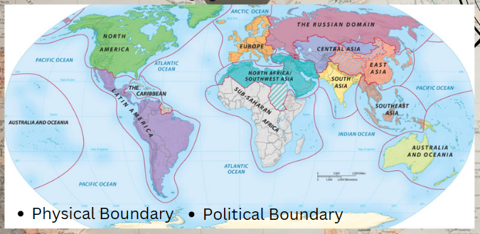

**REGIONAL APPROACH**

1. Logical Division
2. Grouping
3. Homogeneity

* **Formal Regions -** high degree of homogeneity.
* **Functional Regions -** characterized by functional Organization of human occupancy.

**GEOGRAPHY AND INTERDEPENDENCE**  
 The tangible partitioning of space within which different process operate

1. Interdependent
2. World Regions
3. National States
4. Supranational Organizations

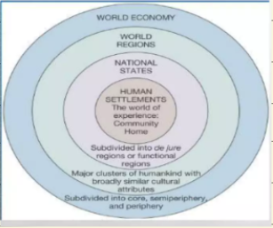

**REGIONALIZATION**

* The classification of individual or areal units. The geographer's equivalent of scientific classicification.

**ECONOMIC AND POLITICAL RESPOND OF COUNTRIES TO GLOBALIZATION**

1. Some are large enough and have a lot of resources to dictate how they participate in the process of global integration. I.e. China
2. Other countries make up for their small size by taking advantage of their strategic location.

**REASONS OF FORMING REGIONAL ASSOCIATION**

* **MILITARY DEFENSE**
* **NORTH ATLANTIC TREATY ORGANIZATION (NATO)**
* Formed during the cold war by western European countries and the United States with the agreement to protect Europe against the threat of the Soviet Union.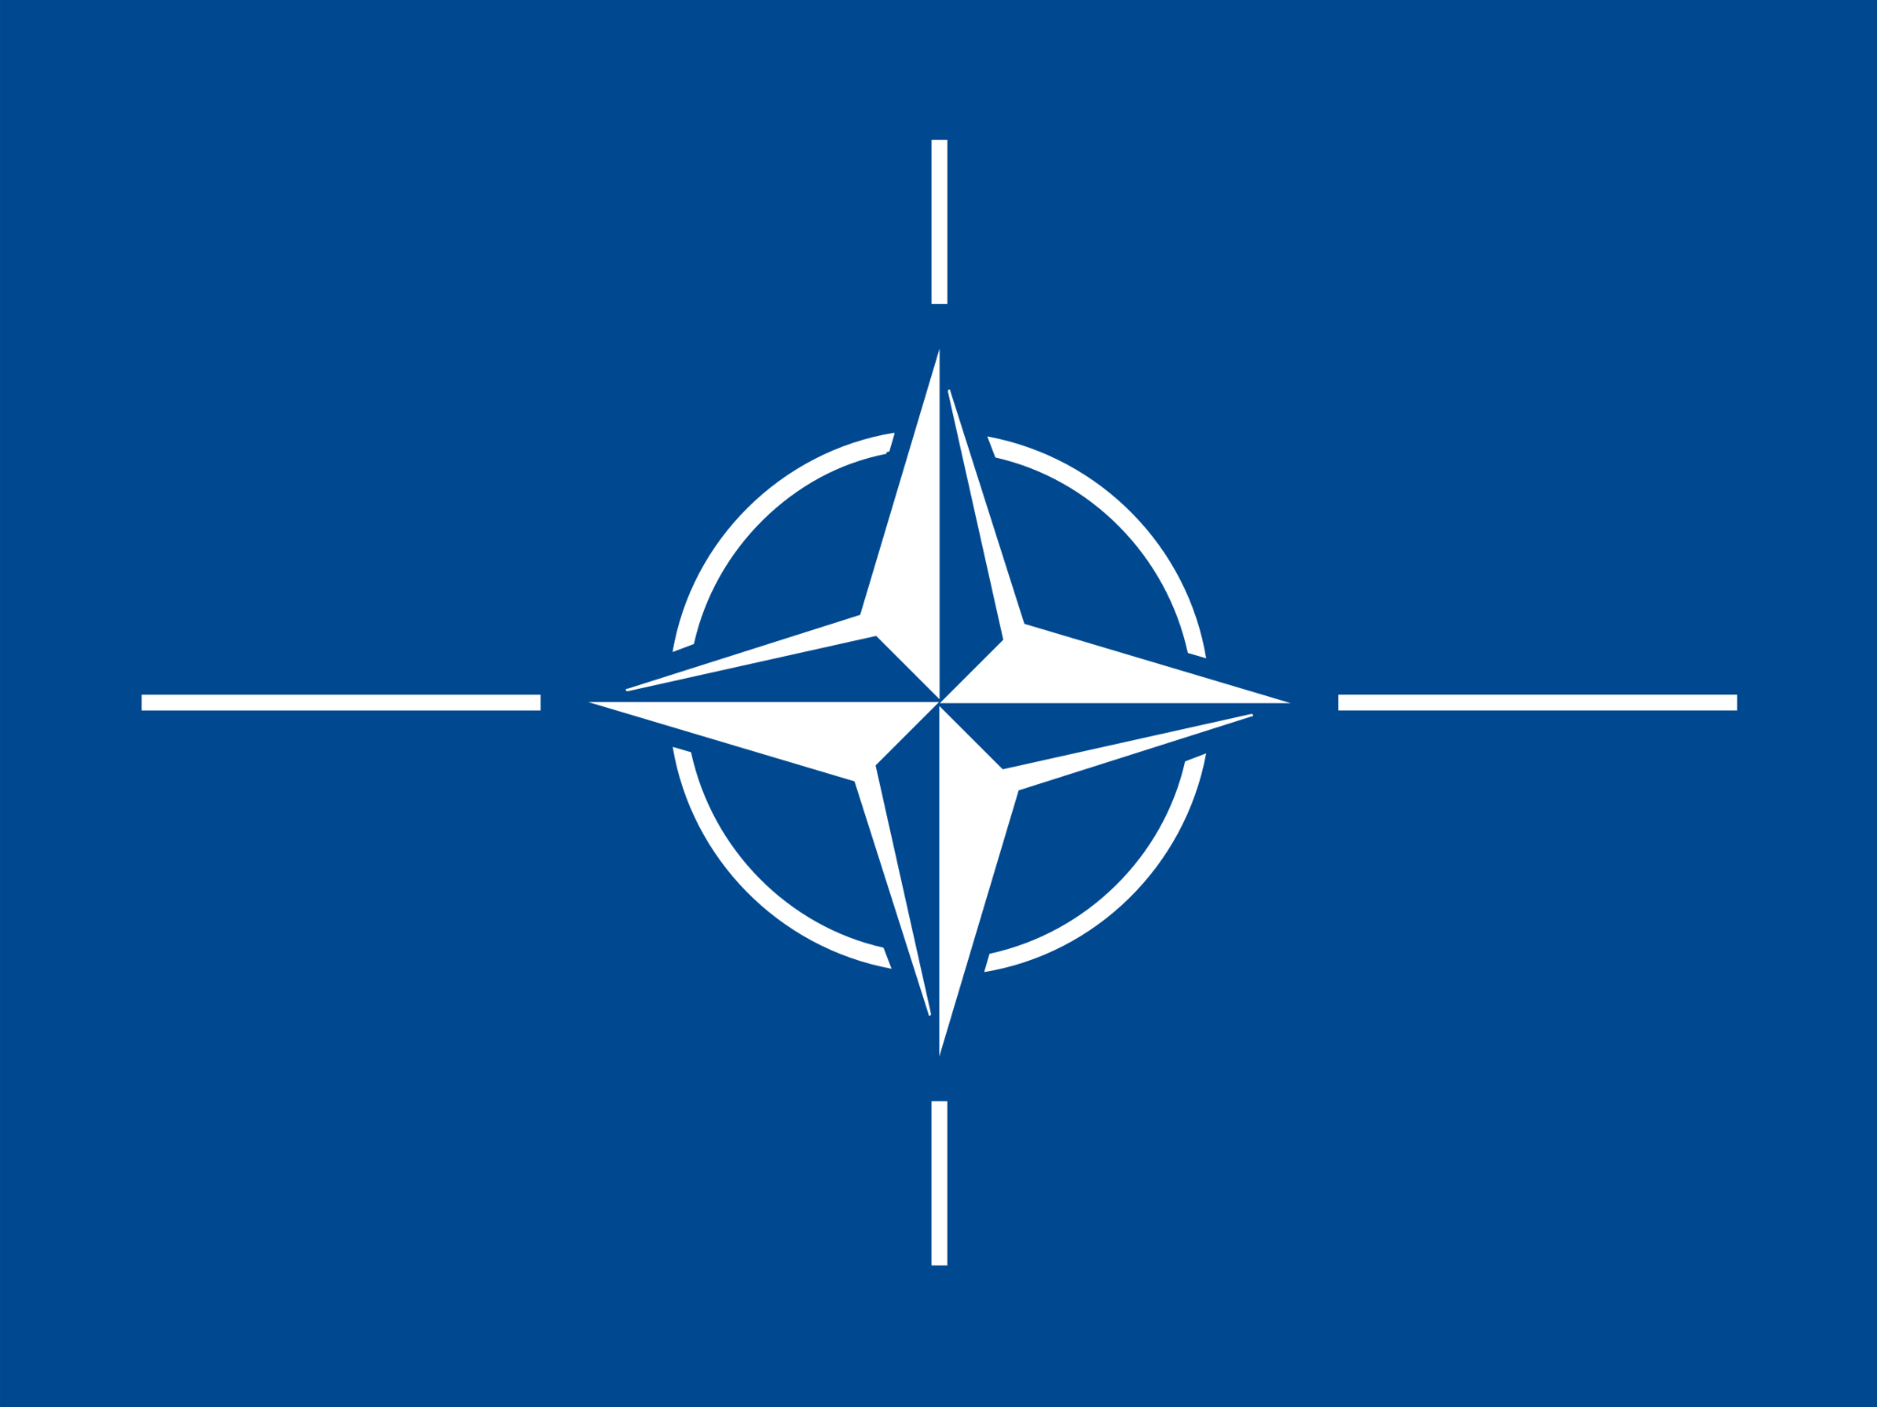
* **WARSAW PACT**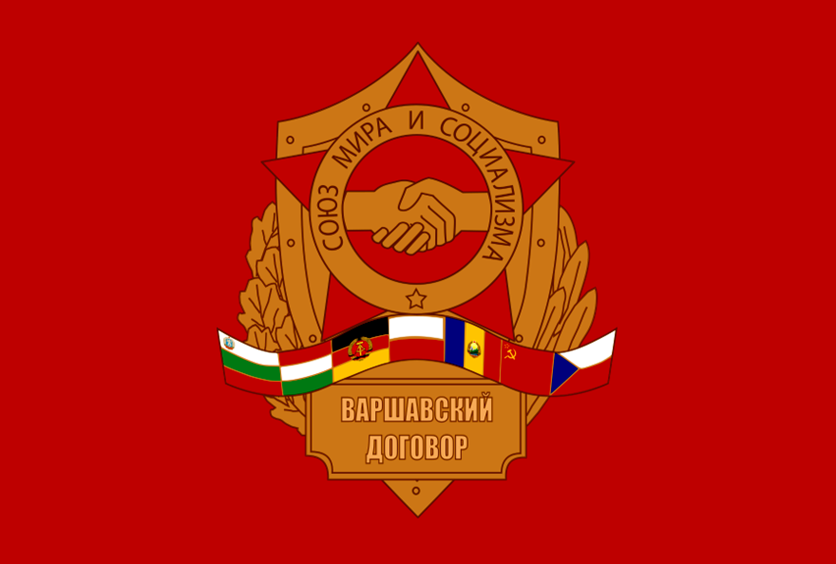
* Regional alliance created by the Soviet Union. It Dissolved in December 1991 alongside the Soviet Union.
* **ECONOMIC CRISIS COMPELS WHEN COUNTRIES COME TOGETHER**
* **PROTECT THEIR INDEPENDENCE FROM THE PRESSURE OF SUPERPOWER POLITICS**
  + The NAM or Non-Aligned Movement is a forum of 120 countries that are not formally alight with or against any major power block. It is the largest grouping of states after the United Nations.

**LESSON 5: Global Divides (The North and the South)**

**North**

* Country: North America, Western Europe, Australia, Japan
* First World
* Rich and Developed
* 95% has enough food and shelter to live and also a functioning education system

**South**

* Country: Latin America, Africa, Asia
* Serves a source for raw material for the north
* Poor and Less Developed
* Only 5% of the population has enough food and shelter

**What is Global Divides?**

* The global divide is about the different factors that affect the improvements or advancement of different places all around the globe. There is pre-division before world war 1 Distance is no longer a problem or issue.
* Global North: rich and industrialized countries
* Global South: poor and developing countries
* The term global divide connotes disparities in income and living conditions between the advanced and developing states.
* [Global Divide (North-South Divide)](https://www.youtube.com/watch?v=1XtyR0btI4o&feature=youtu.be)

**Three worlds model**

1. **Capitalist**

* Is an economic system in which a country's trade, industry, and profits are controlled by private companies, instead of by the people whose time and labor powers those companies.

1. **Communist**

* Communist states in the world are in China, Cuba, Laos, and Vietnam.
* These communist states often do not claim to have achieved socialism or communism in their countries-rather, they claim to be building and working toward the establishment of socialism in their countries.

1. **Developing**

* A poor agricultural country that is seeking to become more advanced economically and socially. It is also known as an LAIC, or a low and middle-income country.
* These countries are characterized by being less developed industrially and have a lower human development index when compared to other countries, and have health risks such as having low access to safe water, as well as sanitation and hygiene problems.

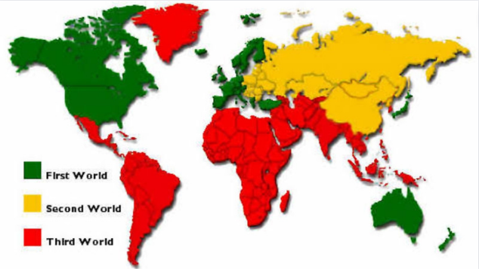

**Four Worlds Model**

**FIRST WORLD**

* Refers to the so-called developed, capitalist, industrial countries roughly, a bloc of countries aligned with the United States after world war II, with more or less common political and economic interests: North America, Western Europe, Japan, and Australia.

**SECOND WORLD**

* Refers to the former communist-socialist, industrial states (formerly the eastern bloc, the territory and sphere of influence of the union of soviet socialist republics) today: Russia, Eastern Europe, Poland and some of the Turk states, Kazakhstan as well as china.

**Soviet Union**

* The Soviet Union's full name was the "Union of Soviet Socialist Republics" or U.S.S.R. "Soviet" comes from the name for workers' councils, and the hammer and sickle on its red flag symbolically represented the labor of the country's workers.

**THIRD WORLD**

* Despite ever evolving definitions, the concept of the 3rd world serves to identify countries that suffer from high infant mortality, low economic development, high levels of poverty, low utilization of natural resources, and heavy dependence on industrialized nations.
* These are the developing and technologically less advanced nations of Asia, Africa, Oceania, and Latin America.

The 3rd world nations - tend to have economies dependent on the developed countries and are generally characterized as poor with unstable governments and having high rates of population growth, illiteracy, and disease.

A key factor is the lack of a middle class-with impoverished millions in a vast lower economic class and a very small elite upper class controlling the country's wealth and resources.

Most third-world nations also have very large foreign debts.

**5 worlds model**

1. **First World Order (High)**

* First World Countries would be the equivalent to Developed Countries (e.g. Canada, US, Germany, etc.)

1. **Second World Order (Moderate)**

* Second World Countries include those that were or are communist and such as Cuba, China, Russia, etc. They have social development characteristics similar to those of First World or Developed countries but their economic development characteristics are more like that of much poorer nations such as Fourth and Fifth World or Developing countries (or vice versa).

1. **Third World Model (On the Way)**

* Third World Countries in this classification would be similar to those in transition such as the Newly Industrialized Countries (e.g. India, China, Brazil, etc.)

1. **Fourth World Order (Lower)**

* Fourth World Countries include those that are only in early stages of transition towards being developed. For example: Rwanda, Swaziland, etc.

1. **Fifth World Order (Lowest)**

* Fifth World Countries show little evidence of even starting a transition towards development, often due to level of poverty or due to being affected by war or natural disaster. For example: Haiti, Afghanistan, Congo, Somalia, etc.

*The global south is made up of Africa, Latin America, and developing Asia including the middle east. The global south "lacks appropriate technology, it has no political stability, the economies are disarticulated, and their foreign exchange earnings depend on primary product exports."*

**Global North and Global South**

[CHAPTER 4: GLOBAL NORTH AND GLOBAL SOUTH || The Contemporary World - Marvin Cabañero](https://youtu.be/_B2kOos0Hh8)

**Comparison between North and South**

|  |  |  |
| --- | --- | --- |
|  | **North** | **South** |
| Political | External Threat | The internal affairs of the nations |
| Economical | Manufacturing | Agriculture |
| Social | Determined by life in the cities  College was reserve for the wealthy | Determine by the upper-class  Small farmers had little or no education |

**Major Differences between North and South**

**North**

* Less population
* High wealth
* High standard of living
* High Industrial Development

**South**

* Large population
* Low wealth
* Low standard of living
* Low Industrial Development

**Reasons of Global Divides**

**Colonialism** is considered to be one of the root causes of global inequality, as it has left a lasting impact on the world that continues to affect countries and their populations today.

**Trade** is one of the reasons why the world is unequal today. It can reinforce existing patterns of economic and political power, allowing some countries to dominate and exploit others.

**Debt** is one of the reasons why the world is unequal today. It can trap countries in cycles of poverty and dependency, leading to economic and political domination by creditor countries and institutions.

**Issue of Global Divides Standard of Living (Factors to lead to low standard of living)**

* Lack of trade and aid
* Insufficient health care servies
* Lack of jobs
* Lack of public transportation
* Distribution of income around the world encourage migration of people from south to north for having a more good income
* Most south countries lost to the competition from the north

**Reasons for Development Gap**

1. Physical
2. Economic
3. Historical

Development gap is the difference in levels of development between the richest and poorest countries in the world. Many believe that the gap between high-income countries (HICs) and low-income countries (LICs) is getting wider

**Classification of Countries**

**Most developed countries.** Developed economy is typically characteristic of a developed country with a relatively high level of economic growth. The standard criteria for evaluating a country's level of development is per capita gross domestic product

**Less develop countries.** A country that does not have a lot of industrial activity and where people have low incomes

**Least developed countries.** Low-income countries confronting severe structural impediments to sustainable development

**Modernization theory** explained the underdevelopment of countries in Asia, Africa, and Latin America primarily in terms of cultural ‘barriers’ to development, basically arguing that developing countries were underdeveloped because their traditional values held them back; other modernization theorists focused more on economic barriers to development

**World system theory** focuses on the importance of the world as a unit, rather than looking at individual countries. It divides the world into three regions: core countries, periphery countries, and semi-periphery countries. Core countries include areas like Western Europe and the United States.

**Dependency theory**

* The local economies are distorted in that they serve mostly the needs of advanced countries but not the needs of local populations
* It argues that the root cause of poverty and underdevelopment is imperialism as well as dependency of poor nations on the rich nations
* Poor societies are not born but made

**Neoliberal Globalization**

According to critics, neoliberal policies aimed at creating a framework for the economy that makes it possible to raise profits by minimizing the costs of investment, reducing social security, and preaching individualism

**GDP (Gross Domestic Product per capita)**

* Average income per person
* This measure of income is a useful way for comparing levels of development.
* Increase in GDP is caused by increase in national productivity.
* In terms of development,using GDP per capita approach was about following the rich industrialized countries.
* Income Inequality-a measure of how the wealth in the economy is distributed among the population

**LESSON 6: ASIAN REGIONALISM IN GLOBALIZATION**

**CLOSING GAP**

* The united nations has developed a program dedicated to narrowing the divide through it millennium development goals.
* This includes improving education and health care, promoting gender equality and ensuring environmental sustainability

**ASIAN REGIONALISM**

* Asian regionalism examines the relationship between ideas and politics, along with the exponential rise of Asia's economy, financial stability, and regional economic integration. Asia's development has had a massively positive impact on people's lives. Most Asian economies have made remarkable progress in reducing poverty.
* During the 1950s and 1960s, the first wave of global regionalism coincided with the formation of ASEAN, which marked the beginning of Asian regionalism. However, rather than economic integration, the bloc's goal was to form a loose security alliance against communist expansion.

**HOW DOES REGIONALISM AFFECT ASIA**

* While Asian regionalism is motivated primarily by a desire to advance welfare in the region, it will not do so at the expense of development elsewhere.
* On the contrary, Asian regionalism has the potential to support global economic growth at a time when other major regions are reaching economic maturity.

**ASIAN REGIONALISM: CONTEXT AND SCOPE**

* In the early stages of Asia's economic takeoff, regional integration proceeded slowly.
* East Asian economies, in particular, focused on exporting to developed country markets rather than selling to each other.
* Initially, they specialized in simple, labor-intensive manufactures.
* Now, though, Asian economies are becoming closely intertwined not because the region's development strategy has changed but it remains predominantly nondiscriminatory and outward-oriented.
* Interdependence is deepening because Asia's economies have grown large and prosperous enough to become important to each other , and because their pattern of production increasingly depends on network that span several Asian economies and involve wide-ranging exchanges of parts and components among the.
* Emerging Asian economies that had opened up their financial market such as Indonesia, Republic of Korea, Malaysia, the Philippines, and Thailand received the most hit but eventually nearly every Asian country was affected.
* Most then used the crisis as an opportunity to pursue wide-ranging reforms in finances as well as in other areas of weakness that the crisis exposed.
* Asia emerged with a greater appreciation of its shared interests and the value of regional cooperation.
* Since the crisis, Asia has not only become more integrated, but also more willing to pull together.

**GROWTH AND INTEGRATION**

* Asian regionalism is emerging against the backdrop of a remarkable half of a century of economic development.
* In the four decades from 1956-1996, East Asian living standards, as measured by real ( inflation adjusted ) output per person, rose at rate faster than ever been sustained anywhere elsewhere.
* Other Asian economies rank in the upper tiers of the world's growth distribution.
* Over the four decades, living standards in the 16 integrating Asian economies analyzed in this study grew at an average of 0.5% a year, while the world as whole averaged only at 1.9%
* These extraordinary results were achieved by economies that differed widely in size; incomes; endowments of natural, human, and capital resources; specialization patterns; political organization; language; culture; and history.

**FLYING IN SEQUENCE**

* Competition in global markets is at the heart of what is now understood as the east Asian development model.
* When the model emerged in the 1950s, its focus on labor- intensive exports was new; the prevailing “big push” development strategy favored large, coordinated investments in a bid to achieve economies of scale, usually in importing competing industries.
* East Asian development instead relied on the region ’ s abundant asset of relatively well-educated, low-wage labor and in time leveraged it with ample savings and investment.
* The model emerged in Japan in the aftermath of world war II.
* Although Japan was already industrialized, the war had devastated its economy and sharply lowered its wages. Access to markets in the US enabled Japan to develop labor-intensive exports, fueling a dramatic rise in savings, investment, and economic growth.

**THE CRISIS AND ITS LEGACY**

* Even with hindsight, though, the events of 1997/1998 seem improbable.
* The crisis struck some of the world’ s most successful economies and, in short order, brought down governments, threatened seemingly well-established firms and institutions, and imposed severe hardship on hundreds of millions of people.
* It proved to be short, and economic activity rebounded quickly.

**RENAISSANCE**

* Since the crisis, Asia has reemerged as the world’ s most dynamic region, experiencing what a new world bank study has called the east Asian renaissance.
* The People ’ s Republic of China (PRC), India, and Vietnam are now the region ’ s— and the world’ s—fastest growing economies.

**ASIAN REGIONALISM IN THE WORLD ECONOMY**

* THE CENTER OF GRAVITY OF THE GLOBAL ECONOMY IS SHIFTING TO ASIA. THE REGION’S ECONOMY IS ALREADY SIMILAR IN SIZE TO THOSE OF EUROPE AND NORTH AMERICA, AND ITS INFLUENCE IN THE WORLD CONTINUES TO INCREASE.
* IN MANY ASIAN COUNTRIES, THE CYCLE OF POVERTY HAS BEEN BROKEN; IN OTHERS, THIS HISTORIC AIM IS WITHIN SIGHT.
* ASIA’S EXTRAORDINARY SUCCESS HAS BROUGHT NEW CHALLENGES—WHILE RAPID ECONOMIC GROWTH REMAINS A PRIORITY, CITIZENS DEMAND THAT IT ALSO BE SUSTAINABLE AND MORE INCLUSIVE.
* ASIA IS NOW SO IMPORTANT TO THE WORLD ECONOMY THAT IT MUST ALSO PLAY A LARGER ROLE IN GLOBAL ECONOMIC LEADERSHIP.
* REGIONAL ECONOMIC COOPERATION IS ESSENTIAL FOR ADDRESSING THESE CHALLENGES.
* ASIA’S EXTRAORDINARY SUCCESS HAS BROUGHT NEW CHALLENGES—WHILE RAPID ECONOMIC GROWTH REMAINS A PRIORITY, CITIZENS DEMAND THAT IT ALSO BE SUSTAINABLE AND MORE INCLUSIVE.

**REGIONAL ECONOMIC COOPERATION**

* REGIONAL ECONOMIC COOPERATION IS AN IMPORTANT MEANS FOR CREATING NEW TRADE, INVESTMENT AND EMPLOYMENT OPPORTUNITIES, ENHANCING ECONOMIC SECURITY, AND ADDRESSING BROADER SOCIOECONOMIC AND ENVIRONMENTAL ISSUES. YET SIGNIFICANT CHALLENGES CONTINUE TO HINDER GREATER COOPERATION AND INTEGRATION

**ECONOMIC COOPERATION ORGANIZATION(ECO)**

* THE ECONOMIC COOPERATION ORGANIZATION OR ECO IS AN ASIAN POLITICAL AND ECONOMIC INTERGOVERNMENTAL ORGANIZATION WHICH WAS FOUNDED IN 1985 IN TEHRAN BY THE LEADERS OF IRAN, PAKISTAN, AND TURKEY.
* IT PROVIDES A PLATFORM TO DISCUSS WAYS TO IMPROVE DEVELOPMENT AND PROMOTE TRADE AND INVESTMENT OPPORTUNITIES.

**LESSON 1: A WORLD OF IDEAS**

**IDEA**

* An idea is *a set of instructions* to produce a new good, to increase quality or to reduce costs.
* An idea is different from a good or a service because it is nonrival. Which means that it can be used again and again simultaneously by many people.
* However, the concept of ideas is not strictly tied to the concept of improving goods and services. In essence it is our thought or a guide that guides us in our course of action

**THE GLOBAL FLOW OF IDEAS**

The global flow of ideas is apparent in the computer, smartphone, e-readers, mp3 players, mp4, and other technologies that fill out everyday lives.

* Measuring the production of ideas and their flow is not easy. Ideas are intangible.
* However, use the number of patent filings as indirect evidence of new ideas. The global flow of ideas is measured by cross-country patent statistics.
* A single patent does not protect an idea worldwide, a single idea can be patented in a number of countries.
* Typically, patents are sought wherever inventors expect their ideas— designs for new products or production processes—to be made, used or sold.
* Therefore, we can use the distribution of patent applications as a proxy for the global flow of ideas.

Quantifying the flow is difficult. However, patent filings can provide indirect evidence on the production of ideas. Further, cross-border patenting, the patenting of idea in several countries can help trace the flow of ideas. What we learn from those data is that idea production has taken off in the developing BRIC (Brazil, Russia, India, China) economies. That idea imports and exports of ideas have grown substantially.

Also in the countries that have been the traditional locus of global idea production, is like the US, Germany, and Japan. We can say that ideas are great engines of economic growth, precisely because everybody can use them simultaneously. Once the cost of creating a new set of instructions – the instructions can be used over and over again at no additional cost. Nobody needs to recreate an idea because it is already available for everybody to use. Therefore, the flow of an idea is as important as the idea itself. Ideas become more valuable as the number of users increases.

**GLOBAL, CULTURE , AND MEDIA**

CULTURE

Culture refers to the unified style of human knowledge, beliefs, and behavior from which people learn, and the ability to communicate knowledge to the next generations. Its development has been mainly influenced by media.

MEDIA

* Media is a carrier of culture. It is a tool for the interaction of people with different cultures.
* The real media is the people.
* Pieterse (2004) asserts that the only outcomes of the influence of globalization on culture are cultural differentialism, cultural convergence, and cultural hybridity.

Media comes from the word, “medium” which is defined as channel, means, or methods. Media is the generic term for all human invented technology that extends the range, speed, or channels of all communication. Media can also be tied to what we call mass media or the media that reach large audiences

How has the media industry contributed to globalization and what role does technology play in this process?

* The media industry facilitates globalization by spreading cultural products across traditional political borders, which can influence the recipient's culture. Technology has accelerated this process by enabling fast communication, transport, and marketing. As a result, the media has become increasingly globalized

**MEDIA’S FIVE STAGES OF DEVELOPMENT**

ORAL COMMUNICATION

* Language became the most important tool for exploring the world and the different cultures.
* Oral communication led to markets, trade, and cross continental trade routes.

Language and culture are are intertwined, with a specific language often being tied to a particular group of people.

Understanding a culture requires understanding its language, which can be transmitted culturally.

Changes in language and culture occur over time, with industrialized countries experiencing more rapid changes due to modern communication and translation services. These changes have facilitated the spread of knowledge across the globe, benefiting society in various fields.

SCRIPT

Script allowed humans to communicate over a larger space and for a much longer duration. It allowed the permanent codification of economic, cultural, religious, and political practice.

Also in script, knowledge, beliefs, and behaviors were written and made available for transmission to the next generation, to the other nations and cultures.

PRINTING PRESS

Printing Press allowed the continuous production, reproduction, and circulation of print materials.

This period of media development affects globalization by transforming various institution such as school, markets, businesses, churches, governments, and many others.

ELECTRONIC MEDIA

Electronic media includes the telegraph, telephone, radio, film, and television.

The wide reach of these media continues to open up new perspectives in the economic, political, and cultural processes of globalization.

The electronic age is the invention of the transistor ushered in the electronic era. People harnessed the power of the transistor that led to the transistor communication and it became more efficient and effective.

DIGITAL MEDIA

Digital media relies on digital codes. It can be created, modified, and stored in any digital electronic device.

Digitalized content is transmitted over the internet and computer networks.

Digital media is also known as new media. Consisting of contents that are organized and distributed on digital platforms. Platforms include internet, social media, and computers.

**OUTCOMES OF THE INFLUENCE OF GLOBALIZATION ON CULTURE**

CULTURAL DIFFERENTIALISM

Cultural differentialism views cultural difference as immutable

As the West and non-Western civilizations interact or are brought in contact through globalization, clash of civilizations such as that of the West and Islam logically follows.

CULTURAL CONVERGENCE

Cultural convergence suggests that globalization engenders a growing sameness of cultures. However, the culture of powerful and progressive countries becomes culture.

CULTURAL HYBRIDITY

It is the mixing and merging of cultures resulting in the creation of new cultural forms in language, food, fashion, arts, music, among others.

GLOCALIZATION

The continuous accommodation and assimilation by local cultures of the cultures of the world due to globalization.

Glocalization is the combination of the words “globalization” and “localization”. The term is used to describe a product or service that is developed and distributed globally but is also adjusted to accommodate the user and consumer in a local market.

**GLOBALIZATION OF RELIGION**

RELIGION

is a collection of cultural systems, belief systems, and world views that establishes symbols that relate humanity to spirituality and to moral values.

Religion is the foundation of modern republics. It is the belief in and worship of a superhuman controlling power, especially a god or gods. It is also may be defined as cultural system or designated behaviors or practices even morals, prophecies, ethics, organizations that relates humanity to supernatural transcendental or spiritual elements.



The major religions of the world mentioned differ in many respects including how each religion is organized and the belief system each upholds.

Other differences include the nature or belief in a higher power, even in the history of how the world and the religion began and the use of sacred text and objects.

1. Christianity → largest religion in the world. It started 2000 years ago in Palestine with Jesus of Nazareth, a charismatic leader who thought his followers about Caritas. The word caritas means charity or treating others as you would like to be treated yourself.
2. Islam → is monotheistic. Monotheistic means they believe only in a single god. It follows the teaching of Prophet Muhammed born in Mecca. Muhammed is seen only as a Prophet, not as a divine being and he is to believe the messenger of Allah or their god who is divine. Islam means peace and submission.

Islam means peace and submission. So, the sacred text of Muslim or the sacred book which is called “Quran”. As with Christianity’s old testament, many of the Quran stories are shared with the Jewish faith and division exists within Islam, but all Muslim are guided by their five beliefs or practices which they sometimes called “pillars”.

Pillars:

● Allah is the only god and Muhammed is his prophet.

● Daily prayer

● Helping those in poverty.

● Fasting as a spiritual practice.

● Pilgrimage to the holy center of Mecca.

1. Hinduism → the oldest religion in the world. Hinduism originated in the Indus River Valley with roughly 1 billion followers. Hinduism is the 3rd largest of world religions. Hindus believe in divided power that can manifest different entities. Hindus also believe in karma and reincarnation.
2. Buddhism → was founded by Siddhartha Gautama. Siddhartha Gautama was said to have given up a comfortable upper-class life to follow one of poverty and spiritual devotion. At the age of 35, he famously meditated under a sacred fig tree and vowed not to rise before he achieved enlightenment called “Bodhi”. After this experience, he became known as Buddha or the enlightened one. So, the followers are drawn to Buddha’s teaching and the practices of meditation and he later established monastic order.

According to Buddha’s teachings, he encourages his followers to lead moral life.

1. Confucianism → was the official religion of China until it was officially abolished when Communist leadership discourage the religious practice in 1949. The religion was developed by Confucius. He is an extraordinary teacher, his lessons were about self-discipline, respect for authority, and tradition and Jen. Jen is a kind treatment of every person which was collected in a book called the Analects. Some religious scholars consider Confucianism more of a social system than a religion because Confucianism focuses on sharing wisdom about moral practices but does not involve any type of specific worship nor does it have formal objects.
2. Taoism → the purpose of life is inner peace and harmony. “Tao” is usually translated as a way or path. The founder of the religion is generally recognized to be a man named Lao Tzu. Their beliefs emphasize the virtue of compassion and moderation. The concept of the Ying-yang symbol came from Taoism and the concept of polar forces or central Taoist ideas. Some scholars have compared these Chinese traditions to their Confucian counterparts by saying that Confucianism is concerned with day-to-day rules of conduct while Taoism is concerned with a more spiritual level of being.
3. Judaism → after their exodus from Egypt in the 13th century, Jews or a nomadic society became monotheistic or worshiping only one god. The Jews' covenant or promise of a special relationship with Yahweh or their god is an important element of Judaism.

Their sacred text is called “Torah” which Christians also follow as the first five books of the bible. The collection of a sacred Jewish or oral interpretation of the Torah is called the Talmud. Jews emphasize moral behavior and action as opposed to beliefs or personal salvation in the next world.

To sum up, religion epitomizes the definition of globalization due to the fact that it can be spread more efficiently than ever before through the use of different technological tools. It is now possible for every religion to spread beyond national borders allowing even small new religious movements to engage in overseas activities and leading to new, unseen religious developments. Small religious developments are also spreading thanks to celebrities for advertising them.

Globalization has a great impact on religion as people and cultures move across the globe, as ideas are mobilized and transported by media technology, religious globalization will go on and on.

**TYPES OF RELIGIOUS ORGANIZATIONS**

**Religion** organizes themselves, their institutions, practitioners, and structures in a variety of fashions. According to sociologists, they say that they use different terms ecclesia, denomination, and sect to define these types of organizations.

**Scholars** are also aware that these definitions are not static. Most religions transition through different organizational phases. For example, Christianity began as a cult and transformed into a sect, and today, it exists as ecclesia.

**Cult** this term is sometimes used interchangeably with the term new religious movement (NRM). These groups are often disparaged as being secretive, highly controlling of members’ lives, and dominated by a single, charismatic leader.

Cults may also exhibit other concerning behaviors, such as demanding excessive financial contributions, controlling members' behavior and beliefs, and creating an us-versus-them mentality towards outsiders. In some cases, cults have engaged in illegal activities, including abuse, fraud, and violence.

**Sects** are groups or subgroups within a larger religious or cultural tradition that have distinctive beliefs, practices, or rituals. They can take many forms, from small, informal groups to large, established organizations.

Some sects may be focused on specific spiritual practices or beliefs, while others may be based on social or political issues. It is important to distinguish between sects and cults, as they are often used interchangeably but have distinct meanings.

Cattle are characterized by the use of coercive or manipulative tactics to recruit and retain members, and may engage in illegal or harmful activities. Sects can offer unique perspectives and experiences for their members, but it's important to be aware of the potential for harmful behavior or beliefs within any group.

**Denomination** is a large mainstream religious organization, but it does not claim to be official or state sponsored.

Denomination is one religion among many. For example, Baptist, African Methodist Episcopal, catholic, and seventh-day Adventists are all Christian denominations.

**Ecclesia** originally referring to a political assembly of citizens in ancient Athens, Greece, now refers to a congestion. In sociology, the term is used to refer to a religious group that most all members of a society belong to.

Ecclesia is considered a national recognized or official religion that holds a religious monopoly and is closely allied with state and secular powers.

One way to remember these religious organizational terms is to think of cults, sect, denomination, and ecclesia representing a continuum with increasing influence in society. Cults are least influential, ecclesia are most influential

LECTURE #2

**GLOBAL POPULATION AND MOBILITY**

**RECAP:**

A global city is a city that is seen as a center of economic, cultural, and political power.

They are characterized by size, population density, and diversity. Examples include New York, London, Tokyo, Singapore, and Dubai.

Global cities are hubs for international finance, trade, and commerce, and are known for their high levels of innovation in fields like science, medicine, and engineering.

However, they also face challenges related to inequality, social unrest, and environmental sustainability. To remain competitive, they need to find innovative solutions to these challenges.

GLOBAL CITY

Also called world city or sometimes alpha city or world center, is a city which is a primary node in the global economic network.

It is an urban centre that enjoys significant competitive advantages and that serves as a hub within a globalized economic system. The concept comes from geography and urban studies, and the idea that globalization is created and furthered in strategic geographic locales according to a hierarchy of importance to the operation of the global system of finance and trade.

A global city is a city that plays a crucial role in the global economic system by being a primary node in the global network of finance, trade, and commerce. It serves as a hub for various industries and attracts global talent and investment. Global cities are characterized by their economic power, cultural vibrancy, political influence, advanced infrastructure, and skilled workforce. The concept of a global city comes from geography and urban studies and reflects the idea that globalization is created and advanced in strategic geographic locations.

SASSEN (1991)

IS USED TO DESCRIBE THE THREE URBAN CENTERS OF NEW YORK, LONDON, TOKYO AS ECONOMIC CENTERS THAT EXERT CONTROL OVER THE WORLD'S POLITICAL ECONOMY. WORLD CITIES ARE CATEGORIZED AS SUCH BASED ON THE GLOBAL REACH OF ORGANIZATIONS FOUND IN THEM.

What makes a city “Global’?

A city is considered "global" when it has a significant impact on the global economy, culture, and politics. A global city is a primary node in the global economic network and serves as a hub within a globalized economic system.

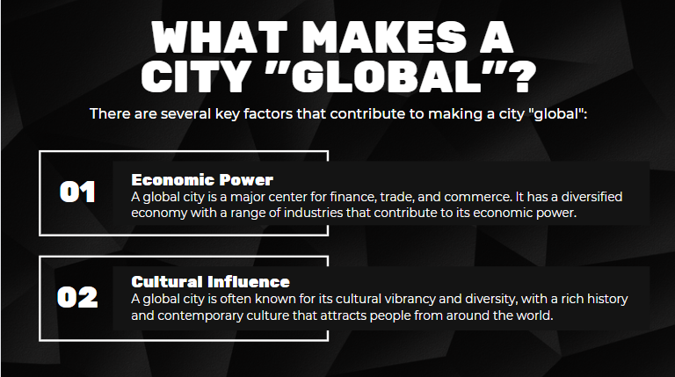

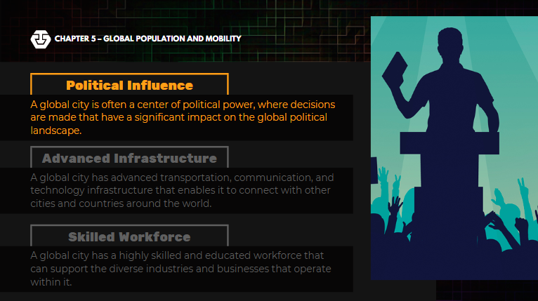

THREE KEY TENDENCIES SEEM TO FOLLOW FROM THESE STRUCTURAL FACTS ABOUT GLOBAL CITIES

1. One is a concentration of wealth in the hands of owners, partners, and professionals associated with the high-end firms in this system.
2. Second is a growing disconnection between the city and its region.
3. Third is the growth of a large marginalized population that has a very hard time earning a living in the marketplace defined by these high-end activities

CHARACTERISTIC OF A GLOBAL CITY

1. A variety of international financial services, notably in finance, insurance, real estate, banking, accountancy, and marketing
2. Headquarters of several multinational corporations
3. The existence of financial headquarters, a stock exchange, and major financial institutions
4. Domination of the trade and economy of a large surrounding area
5. Major manufacturing centers with port and container facilities
6. Considerable decision-making power on a daily basis and at a global level
7. Centers of new ideas and innovation in business, economics, culture, and politics
8. Centers of media and communications for global networks
9. Dominance of the national region with great international significance
10. High percentage of residents employed in the services sector and information sector
11. High-quality educational institutions, including renowned universities, international student attendance, and research facilities
12. Multi-functional infrastructure offering some of the best legal, medical, and entertainment facilities in the country
13. High diversity in language, culture, religion, and ideologies.
14. Hub for a transportation through air, water, and land.

REASONS OF INCREASE IN GLOBAL CITIES

The increase in global cities is linked to the globalization of economies and the centralization of mass production within urban centers.

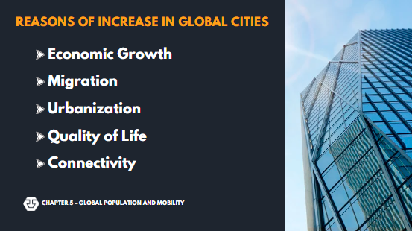

CRITICISMS OF GLOBAL CITIES

Despite playing significant roles in the global economy, global city thesis has been known for being a threat to state-centric perspectives. These cities have been accused of focusing their reach to other global cities and neglecting cities within the national outreach. These cities are more connected to the outside world than to their domestic economy.

CHALLENGES TO GLOBAL CITIES

1. LACK OF JOBS Globalization creates a rush of high paying jobs within global cities creating a chain reaction demanding low income employment to attend to their growing needs. These low income jobs comprise of domestic helpers, maids, cooks, food attendants. Thus implying that flocking to global cities doesn't necessarily mean a good life for everyone.
2. SUPPLY SHORTAGE With the significant rise in the population, several other issues spring out which leads us to the next challenge which is food and water shortage.
3. CLIMATE CHANGE AND RISING TEMPERATURE Cities are considered as the greatest contributor of greenhouse gas emissions and climate change affects more people than others for some are more equipped to handle the effects of climate change.

LECTURE #3

**GLOBAL MIGRATION**

MIGRATION

Migration means crossing the boundary of a political or administrative unit for a certain minimum period (Boyle et al. 1998, chapter 2).

It is classified as either internal migration which refers to a move from one area (a province, district or municipality) to another within one country or International migration which means crossing the frontiers which separate one of the world's approximately 200 states from another.

Many scholars argue that internal and international migration are part of the same process, and should be analyzed together (Skeldon 1997, 9-10).

For better understanding, the migrants come now with different criterion. (Stephen Castles, 2000)

1. Temporary labor migrants- they are popularly known as overseas contract workers who migrate for a limited period in order to work and send remittances to their families left at home.

2. Highly skilled and business migrants- they are the people with special skills and qualification who seek employment through international labor markets for scarce skills.

3. Irregular migrants (also known as undocumented or illegal migrants): people who enter a country, usually in search of employment, without the necessary documents and permits.

4. Return migrants: people who return to their countries of origin after a period in another country.

5. Refugees- is a person residing outside his or her country of nationality, who is unable or unwilling to return because of a 'well-founded fear of persecution on account of race, religion, nationality, membership in a particular social group, or political opinion' (1951 United Nations Convention relating to the Status of Refugees)

6. Asylum-seekers -people who move across borders in search of protection

7. Forced migration - this includes not only refugees and asylum-seekers but also people forced to move by environmental catastrophes or development projects.

8. Family members (also known as family reunion or family reunification migrants) - migration to join people who have already entered an immigration country under one of the above categories.

Migration is thus both a result and a cause of development. Development leads to migration, because economic and educational improvements make people capable of seeking better opportunities elsewhere. It simply means that people from different walks of life, either for purposes of business opportunities, family affairs or even unwanted reasons, are experiencing migration as agents of cultural or political change. As history will tell us, migration has already been a practice ever since the world began.

One of the reason of migration is disparity in levels of income, employment and social well-being between differing areas. With a family to feed or a responsibility to earn, the individual is keen to exert the effort to look for better jobs with better pay. Thus in his search for a greener pasture, he becomes motivated to relocated himself whatever it might cause him. In his search, he will find himself in a certain neighborhood that has been the center of immigrant settlement, with significant business openings, services and convenience which are not usually found in their place of origin. Significantly, these new place houses everything, from the places of worship, ethic groupings and socio-cultural linkages, thus no new immigrant is left out because he can easily blend in. A new perspectives set in where women are likewise given the same opportunities as that of men thus female migration is accommodated as they moved in independently or as heads of households.

Demographers estimate that 247 million people(2018) are currently living outside the countries of their birth.

Ninety percent of them moved for economic reasons while the remaining 10 percent were refugees and asylum-seekers.

The top three regions of origin are Latin Americla(18 percent of global total 2018), followed by Eastern Europe

and Central Asia(16 percent as of 2018)

and the Middle east, North Africa(14 percent as of 2018). On a per country basis, India, Mexico, and China are leading,

with the Philippines, together with Afghanista, only ranking 6th in the world. The top 10 country destinations of these

migrants are mainlyin the West and the Middle East, with the United States topping the list. Fifty percent of global migrants have moved from the developing countries to the developed zones of the world and contribute anywhere from 40-80 percent of their labor force. Their growth has outstripped in the population growth in the developed countries(3 percent versus only 0.6 percent). such that today, according to the think-tank Mckinsey Global Institute.

"First-generation immigrants constitute 13% of the population in western europe. 15 percent in North America, and 48 percent in GCC countries". The majority of migrants remain in the cities. The percentages of migrants in cities are 92 percent in the United States, 95 percent in the United Kingdom, and 99 percent in Australia. Once settled, they contribute enormously to raising the productivity of their hose countries.

The migrant influx has led to a debate in destination countries over the issue of whether migrants are asset of

liabilities to national development. Anti- Immigrant groups and nationalists argue that governments must control

legal immigration and put a stop to illegal entry of foreigners. Many of these anti-immigrant groups are gaining

influence through political leaders who share their belief, Examples include Former US President Donald Trump,

who have been reversing the existing pro-immigration and refugee-sympathetic policies of their states. Most recently,

Trump attempted to ban travel into the US of people from majority- muslim countriesm even those with proper

documentation, he also continues to speak about his eletion promise of building a wall between the United States and Mexico

The wisdom of these government actions has been consistently belied by the data.

A 2011 Harvard Business School survey on the impact of the immigration concluded that the "likelihood and magnitude of the adverse labor market effects for native from immigration are substantially weaker than often perceived."The fiscal impact of immigration on social welfare was noted to be "very small". Furtheremore, the 2013 report on government welfare spending by organization for economic Co-operation and Development(OECD) clearly shows that native-born citizens still receive higher support compared to immigrants.

The massive inflow of refugees from Syria and Iraq has raised alarm bells once again, but has not proved to be as damaging as expected. The International Monetary Fund predicted that the flow of refugees fleeing the war in Syria and Iraq would actually glow Europe's GDP, albeit "Modestly", In Germany, the inflow of refugees from the Middle East has not affected social welfare programs, and had a very little impact on wages and employment. In fact, they have brought much needed labor to the economy instead.

Migration results from inequality

Unequal opportunities lead to migration. Providing people with better access to education, health care and employment opportunities will eventually reduce migration. Investing in the future gives people more opportunities to grow in order to reach their potential, without forcing them to migrate. Migration must be a choice, not an emergency plan that stems from a lack of opportunities.

BENEFITS AND DETRIMENTS FOR SENDING COUNTRIES

Even if 90% of the value generated by migrant workers remains in the in their host countries, they have sent billions back to their home countries. (In 2014, the remittances totaled by. $580 billion). In 2014, India held the highest recorded remittance, ($70 billion), followed by China, ($62 billion), the Philippines ($28 billion), in Mexico ($25 billion). These remittances make significant contribution to the development of small and medium-term industries that help generate jobs. Remittances likewise change the economic and social standing of migrants, as shown by new or renovated homes and their relatives’ access to new consumer goods. The purchasing power of an immigrant family doubles and makes it possible for children to start or continue their schooling.

Yet there remain serious concerns about the economic sustainability of those reliant on migrant money. The Asian Development Bank or ADB? Observes that in countries like the Philippines, remittances. “Do not have significant influence on the other key items of consumption or investment, such as spending on education and health care” remittances. Therefore. May help in lifting. “Households out of property. But not in rebalancing growth, especially in the long run”.

More importantly, global migration is siphoning. Qualified personnel and removing dynamic young workers. This process has so often been referred. To as

"Brain drain”. According again to McKinsey Global Institute, countries in sub-Saharan Africa in Asia have long lost one third of their college graduates, 60% of those who moved on OECD destinations were college graduates, compared to just 9% of the overall population in the country. 52% of Filipinos who live for work in the developed world have tertiary education, which is more than double the 23% of overall Filipino Population.

Furthermore, the loss of professional in certain key roles such as doctors have been detrimental to the migrants’ home countries. In 2006, some 15% of locally trained doctors from 21 sub-Saharan African countries had migrated to United States or Canada. The losses were particularly steep in Liberia, where 43% of doctors left Ghana 30%. Uganda 20%.

Governments are aware of this long-term handicap but have no choice but to continue promoting migrant work as part of state policy because of the remittances impact on GDP. They are equally "concerned with generating jobs for an

under-utilized workforce and in getting maximum possible inflow of worker remittances." Governments are just actively involved in the recruitment and deployment of work, some of them setting up pairs special departments like Bureau Pan Tower Employment and Training in Bangladesh, the Office of the Protector of Immigrants within Egyptian Labor Ministry, the Philippine Overseas Employment. Agency (POAE) The Sustainability. Of migrant dependent economies will partially depend on the strength of this institutions.

**THE PROBLEM OF HUMAN TRAFFICKING**

On top of the issue of brain drain, sending states must likewise protect migrant workers.

in 2012, the International Labour Organization (ILO) identified 21 million men, women, and children as victims of "force labor", an appalling three out every 1,000 persons worldwide. Ninety Percent of the victims (18.7million) are exploited by private enterprises and entrepreneurs 22%. (4.5 million) are sexually abused and 68%. (14.2 million) work under compulsion in agricultural, manufacturing, infrastructure and domestic activities. Human trafficking has been very profitable, earning syndicates, smugglers, and corrupt state officials profit. Of as high as one $150 billion. A year in 2014.

Governments, The Private sector and civil society groups have worked together to combat human trafficking, yet the results remain uneven.

INTEGRATION

The process by which migrants become accepted into society, both as individuals and as groups.Integration refers to a two-way process of adaptation by migrants and host societies… and implies consideration of the rights and obligations of migrants and host societies, of access to different kinds of services and the labour market, and of identification and respect for a core set of values that bind migrants and host communities in a common purpose.

A final issue relates to how migrants interact with their new home countries. They may contribute significantly to a host nation's GDP, but their access to housing, health care, and education is not easy. There is, of course, considerable variation in the economic integration of migrants. Migrants from China, India, and Western Europe often have more success, while those from the Middle East, North Africa, and sub-Saharan Africa face greater challenges in securing jobs. In the United States and Singapore, there are blue-collar as well as white-collar Filipino workers (doctors, engineers, even corporate executives), and it is the professional, white-collar workers that have oftentimes been easier to integrate.

Democratic states assimilate immigrants and their children by granting them citizenship and the rights that go with it (especially public education). However, without a solid support from their citizens, switching citizenship may just be a formality. Linguistic difficulties, customs from the "old country," and, of late, differing religions may create cleavages between migrants and citizens of receiving countries, particularly in the West. The latter accuse migrants of bringing in the culture from their home countries and amplifying differences in linguistic and ethnic customs. Crucially, the lack of integration gives xenophobic and anti-immigrant groups more ammunition to argue that these "new citizens are often not nationals (in the sense of sharing the dominant 19179 culture),"

Migrants unwittingly reinforce the tension by "keeping among themselves. The first-time migrant's anxiety at coming into a new and often "strange" place is mitigated by "local networks of fellow citizens" that serve as the migrant's safety net from the dislocation of uprooting oneself. For instance, the Chinese Consolidated Benevolent Association of California provides initial support for new Chinese migrants, guiding them in finding work or in setting up their small businesses (restaurants and laundromats) in the state and elsewhere. The drawback of these networks is that instead of facilitating integration, they exacerbate differences and discrimination.

Governments and private businesses have made policy changes to address integration problems, like using multiple languages in state documents (in the case of the United States, Spanish and English). Training programs complemented with counseling have also helped migrant integration in Hamburg, Germany, while retail merchants in Barcelona have brought in migrant shopkeepers to break down language barriers while introducing Chinese culture to citizens. Whether these initiatives will succeed or not remains an open question.

CONCLUSION:

Global migration entails the globalization of people. And like the broader globalization process, it is uneven. Some migrants experience their movement as a liberating process. A highly educated professional may find moving to another country financially rewarding. At the other end, a victim of sex trafficking may view the process of migration as dislocating and disempowering.

Like globalization, moreover, migration produces different and often contradictory responses. On the one hand, many richer states know that migrant labor will be beneficial for their economies. With their aging populations, Japan and Germany will need workers from demographically young countries like the Philippines. Similarly, as working populations in countries like the United States move to more skilled careers, their economies will require migrants to work jobs that their local workers are beginning to reject. And yet, despite these benefits, developed countries continue to excessively limit and restrict migrant labor. They do so for numerous factors already mentioned. Some want to preserve what they perceive as local culture by shielding it from newcomers. Other states use migrants as scapegoats, blaming them for economic woes that are, in reality, caused by government policy and not by foreigners.

Yet, despite these various contradictions, it is clear that different forms of global interdependence will ensure that global migration will continue to be one of the major issues in the contemporary world. Countries whose economies have become entirely dependent on globalization and rely on foreign labor to continue growing (e.g. Singapore, Saudi Arabia, and even protectionist Japan) will actively court foreign workers. Likewise, countries like the Philippines with an abundance of labor and a need for remittances will continue to send these workers.

Hence, it is inevitable that countries will have to open up again to prevent their economies from stagnating or even collapsing. The various responses to these movements-xenophobia and extreme nationalism in the receiving countries; dependency in the sending countries will continue to be pressing issues.

LECTURE #4

**SUSTAINABLE DEVELOPMENT GOALS**

Sustainable development is an approach to economic growth and development that seeks to meet the needs of the present without compromising the ability of future generations to meet their own needs. This approach involves balancing economic, social, and environmental considerations to ensure that development is equitable, efficient, and environmentally sustainable. In this report, we will define sustainable development, discuss its history and evolution, and explore its importance in the 21st century.

HISTORY AND EVOLUTION

The concept of sustainable development has its roots in the environmental movement of the 1960s and 1970s, which drew attention to the negative impacts of human activities on the natural world. In the 1980s, the WCED report helped to popularize the concept of sustainable development and to emphasize the need for a more integrated and holistic approach to development.

Since then, sustainable development has become an increasingly important topic of discussion at the international level. In 1992, the United Nations Conference on Environment and Development (UNCED) was held in Rio de Janeiro, Brazil, where the "Agenda 21" action plan was adopted. This plan outlined a set of sustainable development goals and strategies for achieving them, and it has since served as a framework for sustainable development efforts around the world.

In the years since the Rio conference, sustainable development has continued to evolve and expand. Today, it encompasses a wide range of issues and challenges, including climate change, poverty, inequality, and environmental degradation. It is also increasingly recognized as a key driver of innovation and economic growth, as businesses and governments seek to develop more sustainable and resilient systems and technologies.

IMPORTANCE OF SUSTAINABILITY DEVELOPMENT IN THE 21ST CENTURY

Sustainable development is more important than ever in the 21st century, as the world faces a range of interconnected challenges, including climate change, biodiversity loss, and social inequality. These challenges are affecting people and communities around the world, and they require a coordinated and holistic approach to address them.

Sustainable development offers a framework for meeting these challenges, by promoting economic, social, and environmental sustainability. It emphasizes the need to balance these systems to achieve long-term sustainability and to ensure that all members of society have access to the resources and opportunities they need to lead fulfilling lives.

Moreover, sustainable development is essential for achieving the United Nations' Sustainable Development Goals (SDGs), which aim to end poverty, protect the planet, and ensure that all people enjoy peace and prosperity by 2030. These goals cannot be achieved without a commitment to sustainable development, and they offer a roadmap for governments, businesses, and individuals to work together to create a more sustainable and equitable world.

CLIMATE CHANGE

Climate change refers to the long-term changes in global temperature, precipitation, and other climate patterns that have been observed in recent decades. These changes are primarily driven by human activities, particularly the burning of fossil fuels such as coal, oil, and gas. The resulting increase in greenhouse gas emissions has led to a gradual warming of the planet, which has in turn had a wide range of impacts on the natural world and human society.

Climate change can have significant negative impacts on sustainable development. It can lead to more frequent and intense natural disasters such as floods, droughts, and wildfires, which can damage infrastructure, harm ecosystems, and endanger human lives. Climate change can also cause sea level rise, leading to coastal erosion and loss of land, and can affect agriculture and food security.

In addition to the environmental impacts, climate change can also have economic and social impacts, affecting businesses, communities, and individuals. For example, extreme weather events can disrupt supply chains, leading to economic losses and job losses. Climate change can also worsen poverty and inequality, as vulnerable communities are often the hardest hit by its effects.

To address these challenges, sustainable development efforts must prioritize climate action and reduce greenhouse gas emissions, while also building resilience to the impacts of climate change. This can involve implementing sustainable practices in industries such as energy, transportation, and agriculture, as well as investing in climate adaptation measures such as infrastructure improvements and disaster preparedness.

BIODIVERSITY LOSS

Biodiversity loss refers to the decline in the variety and number of species in a particular area or globally. The loss of biodiversity has a significant impact on ecosystems, as it disrupts the intricate balance between species and their interactions, which can lead to the collapse of entire ecosystems. Biodiversity Loss is caused by human activities such as:

1. DEFORESTATION is the permanent removal of forests or woodlands, often for commercial or agricultural purposes. Deforestation also disrupts the intricate balance between species and their interactions, which can lead to the collapse of entire ecosystems and the loss of biodiversity.
2. POLLUTION refers to the introduction of harmful substances or products into the environment, including air, water, and soil. It is a major environmental issue that has significant impacts on human health, wildlife, and ecosystems.
3. OVERFISHING is the practice of harvesting fish and other marine life from the oceans at a rate that exceeds the ability of the population to replenish itself.

STRATEGIES FOR ENVIRONMENTAL CONSERVATION

1. REDUCE, REUSE RECYCLE is a popular environmental slogan that promotes reducing waste, conserving natural resources, and minimizing the negative impacts of human activities on the environment.
2. REDUCE WATER WASTE Water is a finite resource, and conserving it is important for ensuring that we have enough water to meet the needs of current and future generations. By reducing water waste, we can help ensure that we are using water in a sustainable way.
3. ADOPT A SUSTAINABLE TRANSPORTATION PRACTICES Encouraging the use of public transportation, biking, and walking can reduce carbon emissions and decrease the use of fossil fuels.

SOCIAL SUSTAINABILITY

refers to the ability of a society to meet the needs of its members while ensuring social well-being, justice, and equity for present and future generations. It involves creating and maintaining social systems that promote equality, diversity, and inclusion, and that support the health and well-being of all individuals and communities.

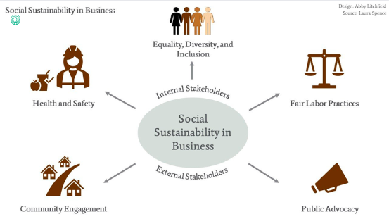

INTERNAL

Internal Stakeholders play an important role in promoting social sustainability within a company. By working together to support diversity, inclusion, ethical business practices, and social responsibility.

EXTERNAL

External Stakeholders can play a crucial role in promoting social sustainability by working together with companies to promote sustainable business practices, raise awareness about environmental and social issues, and advocate for social responsibility and ethical business practices.

ECONOMIC SUSTAINABILITY

Economic sustainability refers to practices that support long-term economic growth without negatively impacting social, environmental, and cultural aspects of the community.

THE ECONOMIC DIMENSION SUSTAINABILITY

The Economic Dimension of Sustainability concerns the organization’s impacts on the economic conditions of its stakeholders, and on economic systems at local, national, and global levels.

The Economic Category illustrates the flow of capital among different stakeholders, and the main economic impacts of the organization throughout society

Within the economic category, there are four material aspects:

1. Economic Performance;
2. Market Presence;
3. Indirect Economic Impacts;
4. Procurement Practices.

Each of these four aspects, meets its own indicators that provide information on the development or economic effects of the organization with regard to each aspect.

ECONOMIC PERFORMANCE

* Direct economic value generated and distributed
* Financial implications and other risks and opportunities for the organization´s activities due to climate change
* Coverage of the organization´s defined benefit plan obligations
* Financial assistance received from government

MARKET PRESENCE

* Ratios and standard entry level wage by gender compared to local minimum wage at significant locations of operation.
* Proportion of senior management hired from the local community at significant locations of operation.

INDIRECT ECONOMIC IMPACT

* Development and impact of infrastructure investment and services supported.
* Significant indirect economic impacts, including the extend of impacts.

PROCUREMENT PRACTICES

* Proportion of spending on local suppliers at significant locations of operation.

SUSTAINABLE CONSUMPTION AND PRODUCTION

Sustainable Consumption and Production (known as SCP) is about doing more and better with less. It is also about decoupling economic growth from environmental degradation, increasing resource efficiency and promoting sustainable lifestyles.

“The use of services and related products, which respond to basic needs and bring a better quality of life while minimizing the use of natural resources and toxic materials as well as the emissions of waste and pollutants over the life cycle of the service or product so as not to jeopardize the needs of future generations”.

SCP is a holistic approach and is about systemic change. It is built around three main objectives:

1. Decoupling environmental degradation from economic growth.
2. Applying life cycle thinking.

DECOUPLING ENVIRONMENTAL DEGRADATION FROM ECONOMIC GROWTH

* This is about doing more and better with less, increasing net welfare gains from economic activities by reducing resource use, degradation and pollution along the whole life cycle, while increasing quality of life. ‘More’ is delivered in terms of goods and services, with ‘less’ impact in terms of resource use, environmental degradation, waste and pollution.

APPLYING LIFE CYCLE THINKING

* This is about increasing the sustainable management of resources and achieving resource efficiency along both production and consumption phases of the lifecycle, including resource extraction, the production of intermediate inputs, distribution, marketing, use, waste disposal and re-use of products and services.

GREEN ECONOMY

The role of Green Economy, Sustainable Consumption and Production and Resource Efficiency for Sustainable Development: Sustainable Consumption and Production aims to improve production processes and consumption practices to reduce resource consumption, waste generation and emissions across the full life cycle of processes and products, while Resource Efficiency refers to the ways in which resources are used to deliver value to society and aims to reduce the amount of resources needed and emmisions and waste generated, per unit of product or service. The Green Economy provides a macro-economic approach to sustainable economic growth with a central focus on investments, employment and skills.

CIRCULAR ECONOMY

The circular economy is oriented to nature as its role model. In essence, the concept of the circular economy aims to keep raw materials in a closed loop. In this way, resources are maximally used, the need for new ones is reduced, waste is avoided and the life cycle of products is increased. In short, the waste of today becomes the raw material of tomorrow - the same as in nature.

In this way, the circular economy differs from the current economic system the linear system, in which products are manufactured, used and disposed of.

**HUMAN RIGHTS IN SOCIAL SUSTAINABILITY**

HUMAN RIGHTS

Human rights are a critical aspect of social sustainability, as they ensure that individuals and communities are treated with dignity and respect, and are able to live fulfilling lives.

**SUSTAINABLE DEVELOPMENT GOALS (SDG)**

THE SUSTAINABLE DEVELOPMENT GOALS (SDGS) ARE A SET OF 17 GLOBAL GOALS ESTABLISHED BY THE UNITED NATIONS GENERAL ASSEMBLY IN 2015 AS PART OF THE 2030 AGENDA FOR SUSTAINABLE DEVELOPMENT. THE SDGS ARE INTENDED TO BE A UNIVERSAL CALL TO ACTION TO END POVERTY, PROTECT THE PLANET, AND ENSURE PEACE AND PROSPERITY FOR ALL PEOPLE.

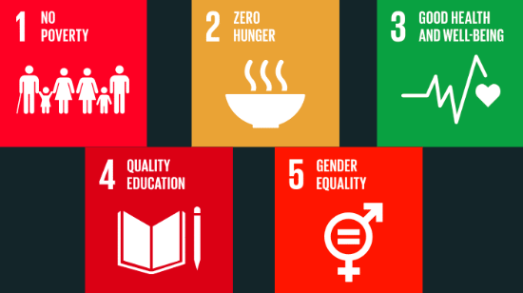

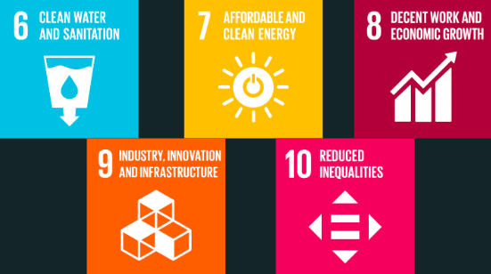

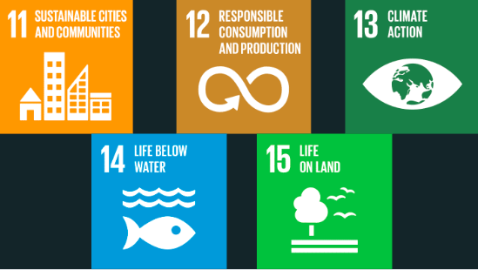

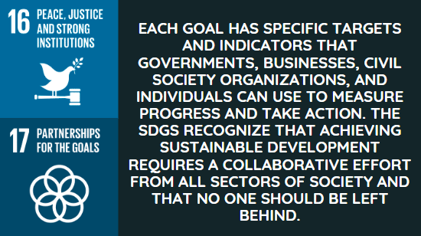

LECTURE #5

**GLOBAL CITIZENSHIP**

WHAT IS GLOBAL CITIZENSHIP

Global citizenship refers to the idea that individuals have a sense of belonging to a larger global community and that they have a responsibility to act as active and engaged members of that community. It involves recognizing and respecting the diversity of cultures, values, and perspectives that exist around the world and working towards a common goal of creating a more just, peaceful, and sustainable world.

Global citizenship can be cultivated through education, travel, and other experiences that expose individuals to different cultures and perspectives. It is an important concept for creating a more interconnected and harmonious world

**Global citizenship encompasses a wide range of values and behaviors, such as:**

* Recognizing and respecting human rights, including the rights of marginalized and vulnerable populations.
* Promoting social justice and equality, and working to eliminate discrimination and inequality.
* Practicing environmental sustainability, including reducing carbon footprints and promoting sustainable development.
* Being aware of global issues and challenges, such as poverty, conflict, and climate change, and working to address them
* Embracing cultural diversity and promoting cross-cultural understanding and communication
* Engaging in global dialogue and collaboration to find solutions to common problems.

HISTORY OF GLOBAL CITIZENSHIP

The concept of global citizenship has a long history that can be traced back to ancient philosophical and religious traditions. For example, Greek philosopher Diogenes famously claimed that he was a "citizen of the world," rejecting the idea of narrow allegiance to a particular city-state. In Buddhism, the idea of interconnectedness and compassion for all living beings is central to the concept of global citizenship.

In more recent history, the idea of global citizenship has been shaped by events such as the rise of globalization, the growth of international organizations like the United Nations, and the increasing awareness of global issues like poverty, inequality, and climate change. The concept has been embraced by a diverse range of scholars, activists, and organizations, and has been used to promote a variety of values and goals.

PHILOSOPHICAL PERSPECTIVE

From a philosophical perspective, the concept of global citizenship is often linked to ideas of moral and political responsibility. Some philosophers argue that individuals have a moral obligation to act as global citizens, recognizing the interconnectedness of all people and the need to work together to solve common problems. Others emphasize the importance of political institutions and governance structures that promote global citizenship and cooperation.

IMPORTANCE OF GLOBAL CITIZENSHIP IN TODAYS INTERCONNECTED WORLD

Global citizenship is increasingly important in today's interconnected world because the problems we face are global in nature, and require collective action to address. For example, issues like climate change, economic inequality, and political instability affect people all around the world, and cannot be solved by any one country or individual acting alone.

Global citizenship also helps to promote understanding and tolerance across cultural and national boundaries, which is increasingly important in an era of rising nationalism and polarization. By recognizing the diversity of perspectives and values that exist around the world, individuals can build bridges between different communities and work towards greater harmony and cooperation.

**HUMAN RIGHTS AND SOCIAL JUSTICE**

Human rights are rights we have simply because we exist as human beings - they are not granted by any state. These universal rights are inherent to us all, regardless of nationality, sex, national or ethnic origin, color, religion, language, or any other status

THREE TYPES OF HUMAN RIGHTS

1. CIVIL RIGHTS are entitlements provided by a certain locality to its public constituents. This will also include the right to have and to be treated with dignity.
2. POLITICAL RIGHTS are administrative entitlements provided by a specific government.
3. SOCIAL RIGHTS are entitlements related to public services and to social protection.

UNDERSTANDING HUMAN RIGHTS AND SOCIAL JUSTICE FROM A GLOBA PERSPECTIVE

From a global perspective, human rights and social justice involve recognizing the inherent dignity of every person and ensuring that they have access to basic needs, such as food, shelter, healthcare, education, and fair treatment under the law. This will includes:

1. Access to education
2. Gender Equality
3. Immigration and refugee rights
4. Environmental Justice
5. Racial and ethnic equality

**EXAMINING ISSUES RELATED TO SOCIAL INEQUALITY, DISCRIMINATION, AND MARGINALIZATION**

SOCIAL INEQUALITY

Social inequality refers to the unequal distribution of resources, opportunities, and privileges among individuals and groups within a society. This can manifest in various forms, such as economic inequality, gender inequality, racial inequality, and more. These issues are intimately linked with human rights and social justice, as they directly affect an individual's ability to access and enjoy their fundamental rights.

DISCRIMINATION

Discrimination is a widespread issue in global human rights and social justice, affecting individuals and communities around the world. Discrimination can be based on various factors such as race, ethnicity, gender, sexuality, religion, disability, and age. Discrimination can result in unequal access to opportunities, resources, and services, as well as unequal treatment and outcomes.

MARGINALIZATION

Marginalization refers to the process of exclusion or deprivation of certain groups or individuals from full participation in society and access to resources, opportunities, and rights. This can occur on individual, community, or societal levels and is often the result of systemic inequalities, discrimination, and prejudice.

**THE ROLE OF GLOBAL CITIZENSHIP IN PROMOTING HUMAN RIGHTS AND SOCIAL JUSTICE**

It represents the universal recognition that basic rights and fundamental freedoms are inherent to all human beings, inalienable and equally applicable to everyone, and that every one of us is born free and equal in dignity and rights.

a permanent tribunal that prosecutes individuals for genocide, crimes against humanity, war crimes, and crimes of aggression. The ICC plays an important role in holding individuals accountable for human rights violations and promoting the rule of law.

**INTERNATIONAL RELATIONS AND DIPLOMACY**

**International relation**s is the study of the relationships and interactions between states, as well as between states and other non-state actors such as international organizations, multinational corporations, and non-governmental organizations.

International relations attempts to explain the interactions of states in the global interstate system, and it also attempts to explain the interactions of others whose behavior originates within one country and is targeted toward members of other countries.

**Diplomacy**, on the other hand, refers to the practice of conducting negotiations and maintaining relationships between states and other international actors. Diplomats work to build relationships and trust between nations, negotiate treaties and agreements, and help resolve conflicts.

HOW DOES INTERNATIONAL RELATIONS WORKS?

International relations work by examining the interactions and relationships between countries and other international actors in the global arena. Here are some ways that international organizations promote global citizenship:

* Diplomacy
* International Organizations
* International Law
* Economic Interactions

HOW DOES DIPLOMACY WORKS?

Diplomacy works by facilitating communication, negotiation, and cooperation between different countries and international actors. Diplomats use various methods and strategies to achieve these goals, including:

* Establishing diplomatic relations
* Conducting negotiations
* Building trust and relationships
* Providing advice and analysis
* Representing their country

DIPLOMATS AND THEIR ROLE IN INTERNATIONAL RELATIONS

Diplomats are government officials who are responsible for representing their country's interests in international relations. They work to establish and maintain relationships with other countries and international actors, negotiate agreements and treaties, provide information and advice to their home government, and promote their country's foreign policy objectives.

INTERNATIONAL INSTITUTIONS AND ORGANIZATIONS AND THEIR ROLES TO GLOBAL CITIZENSHIP

International institutions and organizations are entities that are created by multiple countries to work towards a common goal or address a particular issue in international relations. These institutions and organizations vary in their mandate, scope, and membership, but all aim to facilitate cooperation and collaboration among countries and promote peace, stability, and development on a global scale.

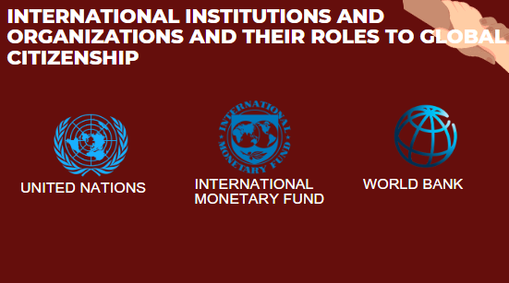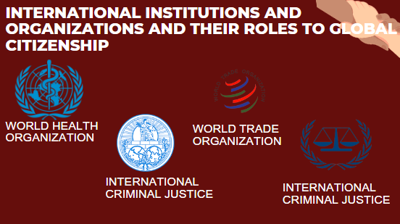

International organizations play an important role in promoting global citizenship by working towards the achievement of the United Nations Sustainable Development Goals (SDGs), which aim to address global challenges such as poverty, inequality, climate change, and conflict. Here are some ways that international organizations promote global citizenship:

* Raising awareness
* Advocating for policies
* Building partnerships
* Providing resources
* Encouraging participation

GLOBAL CITIZENSHIP AND INTERNATIONAL RELATIONS

Global citizenship is relevant to international organizations because it aligns with their mission and goals of promoting international cooperation, social justice, and sustainable development. International organizations are in a unique position to promote global citizenship by addressing global challenges such as poverty, inequality, climate change, and conflict.

GLOBAL CITIZENSHIP TOWARDS A PEACEFUL AND COOPERATIVE WORLD

Global citizenship plays an important role in promoting a peaceful and cooperative world by encouraging individuals to think beyond national boundaries and to recognize their shared humanity. It emphasizes the importance of cooperation, collaboration, and dialogue across different cultures and societies, and seeks to build bridges between people and communities.

**UNDERSTANDING THE ROLE OF SOCIAL CHANGE IN PROMOTING GLOBAL CITIZENSHIP**

**Global citizenship: Embracing our interconnectedness**

* Global citizenship recognizes that we are all interconnected as members of a global community.
* It encourages individuals to transcend national boundaries and embrace a sense of belonging to the world at large.
* Global citizenship emphasizes our shared values, rights, and responsibilities.

**Importance of global citizenship in addressing global challenges**

* Global citizenship plays a crucial role in addressing global challenges effectively.
* It recognizes the need for collective action and individual responsibility.

Global citizenship promotes a sense of accountability towards the world at large.

**Definition of Social Change**

* Social change refers to the transformation of societal structures, values, and behaviors.
* It involves efforts to bring about positive and progressive changes in various aspects of society.
* Social change can occur at different levels, including individual, community, institutional, and systemic levels.

**Ways in Which Social Change Promotes Global Citizenship**

EDUCATION AND AWARENESS

Foster global citizenship through educational programs, curriculum integration, and awareness campaigns that emphasize the importance of interconnectedness and global issues.

Social change initiatives raise awareness about global issues, such as poverty, inequality, climate change, and human rights violations. By providing education and information, these initiatives help individuals understand the interconnected nature of these challenges and the impact they have on people around the world. This knowledge encourages a sense of global citizenship and motivates individuals to take action.

ENCOURAGING EMPATHY AND CULTURAL UNDERSTANDING

Promote empathy by encouraging individuals to learn about and appreciate different cultures, perspectives, and experiences.

By highlighting the stories and struggles of marginalized communities, social change efforts foster understanding and compassion. This empathy helps break down barriers and encourages individuals to recognize the shared humanity among people worldwide, reinforcing the idea of global citizenship.

ENGAGING IN SUSTAINABLE AND ETHICAL PRACTICES

Encourage individuals to adopt sustainable lifestyles, support ethical consumption, and advocate for environmentally-friendly policies.

Engaging in sustainable and ethical practices is vital for a responsible future. This includes reducing waste, conserving resources, supporting fair labor, practicing responsible consumption, and transparent communication. By embracing these practices, we contribute to a sustainable and ethical world.

ADVOCACY AND COLLECTIVE ACTION

Empower individuals to use their voices to advocate for social justice, human rights, and sustainable development. Encourage collective action through community organizing, partnerships, and collaboration.

Advocacy and collective action involve individuals or groups joining forces to address issues and promote social change. By setting goals, building coalitions, raising awareness, engaging decision-makers, and mobilizing supporters, advocates can influence policies and create a more just society. Strategies include using media, monitoring progress, and collaborating with experts. Persistent efforts and adaptive strategies contribute to positive societal transformation.

**STRATEGIES FOR PROMOTING SOCIAL CHANGE AND ADVOCACY**

**Raising Awareness**

* Raising awareness plays a crucial role in promoting social change.
* It involves informing the public about the issue at hand and generating widespread attention.
* Some effective ways to raise awareness include organizing campaigns, hosting events, utilizing social media platforms, and partnering with local communities and media outlets.
* These activities help educate and engage the public, ensuring that the issue receives the attention it deserves.

**Building Alliances and Coalitions**

* Collaboration and building alliances are vital for successful advocacy.
* By forming partnerships with like-minded organizations, community groups, and individuals, we can amplify our voice and combine efforts for a greater impact.
* Alliances and coalitions allow for diverse perspectives and expertise to come together, resulting in stronger advocacy strategies.

**Lobbying and Advocacy Campaigns**

* Lobbying and advocacy campaigns are effective strategies for influencing policymakers and decision-makers.
* Lobbying involves meeting with legislators, government officials, and other influential individuals to present our case, share data and evidence, and propose specific policy changes.
* Additionally, organizing advocacy campaigns such as letter-writing campaigns, petitions, and rallies can help generate public pressure and support for our cause.

**Grassroots Mobilization**

* Grassroots mobilization empowers individuals and communities at the local level to take action.
* By organizing and mobilizing grassroots support, we build a strong base of supporters and create a network of individuals actively involved in promoting change.
* Grassroots movements have the power to bring about significant social transformations.

**Engaging in Dialogue**

* Dialogue plays a crucial role in promoting understanding, challenging stereotypes, and building consensus for change.
* Facilitating open discussions through public forums, workshops, and interactive platforms allows people to share their perspectives and learn from one another.
* Engaging in dialogue helps bridge gaps and fosters collaboration among stakeholders.

**Support Policy and Legal Reforms**

* Advocating for policy and legal reforms is crucial for creating lasting social change.
* By conducting research, drafting policy proposals, and working with experts, we can develop evidence-based solutions.
* Collaboration with lawmakers, advocacy groups, and legal professionals is key to pushing for necessary changes in legislation, regulations, and institutional practices.

**Education and Empowerment**

* Education and empowerment are vital components of social change.
* Through educational materials, workshops, and skill-building initiatives, we can empower individuals to actively participate in advocacy efforts.
* When people are knowledgeable and equipped with tools, they can make a significant impact and sustain momentum.

**Successful Global Citizenship Initiatives and Campaigns**

**United Nations' Sustainable Development Goals (SDGs)**

The United Nations' Sustainable Development Goals (SDGs) are a set of 17 global goals aimed at ending poverty, protecting the planet, and ensuring prosperity for all. The SDGs provide a framework for governments, businesses, and individuals to work together towards a sustainable future.

**Global Citizen**

Global Citizen is a movement that seeks to end extreme poverty by 2030. They organize events, concerts, and campaigns to raise awareness and mobilize action on issues such as education, health, gender equality, and climate change. They also run a rewards program where people can take action and earn points to win tickets to concerts and events.

**350.org**

350.org is a global grassroots movement that focuses on climate change activism. Their goal is to reduce atmospheric carbon dioxide levels to 350 parts per million, which is considered the safe upper limit to avoid catastrophic climate change. They organize campaigns, protests, and educational initiatives to raise awareness and drive policy change.

**Amnesty International**

is a worldwide human rights organization that works to protect people from human rights abuses. They conduct research, campaign for policy changes, and advocate for the rights of individuals and communities facing injustice. Their efforts have led to the release of political prisoners and the enactment of legislation protecting human rights.

**Teach for All**

is a global network of organizations that recruit and train exceptional graduates to become teachers in underserved communities. Their aim is to provide quality education and equal opportunities to all children, regardless of their socio-economic background. The network operates in over 50 countries, working towards educational equity and systemic change.

**Earth Hour**

is a global grassroots movement organized by the World Wildlife Fund (WWF). Every year, millions of people turn off their lights for one hour to raise awareness about climate change and promote sustainable living. The initiative has grown into a symbolic event that encourages individuals, communities, and businesses to take action beyond the hour.

**Human Rights Watch**

is an international non-governmental organization that investigates and reports on human rights abuses around the world. Through their research and advocacy work, they aim to hold governments and other actors accountable for their actions and promote respect for human rights.